Ability Works Australia Newsletter
  - June 2025

In this issue
A note from the CEO 3
Employee shoutouts 4
Spotlight 6
Around the building 8
Evacuation process 8
Stairs 8
Expanding our inventory capacity 9
Workplace dress code and hygiene standards (plus activity) 10
A visit from Transurban 13
Painting of cooling fan clutch kits for Norman G Clark 15
Updates from the Employee Representative Committee (ERC) 16
Inclusive Design 18
Validating Ability Works core values through focus group research 18
Ability Works partners with Alstom for human-centered design testing 21
Accessibility for non-profit organisations 22
Customised Employment 24
Participant acknowledgement 24
Employee input 25
Activities 31
Photo gallery 33

A note from the CEO
Dear employees, families and carers
It’s hard to believe it’s already June. As many of you know, in May, I shared that I would be stepping down as CEO of Ability Works. Since then, I’ve been overwhelmed by the kindness and warmth shown to me, especially from those of you who took the time to write with generous messages. I want to sincerely thank you. I have not had the chance to respond to each note individually, but your words have meant a lot.
In true Ability Works spirit, life here continues to thrive. This edition of the newsletter captures that energy perfectly — from incredible shoutouts for Josh, Wendy and George, to well-deserved awards for Hanan, Warrick, Daniel and Sam. I also loved reading about the success of our Customised Employment participant Jayden, and the inspiring contributions from our Inclusive Design and ERC teams.
What makes Ability Works so special isn’t just the work we do — it’s the people who bring it to life. Every story in this newsletter is a reminder of how far we’ve come together, and the strong, values-led culture that continues to grow.
Thank you for the part you play in making this organisation the vibrant, inclusive and purpose-driven place it is. I look forward to seeing what the next few months bring, and I remain full of admiration for all that you do.
Warmest regards,
Sue Boyce
CEO
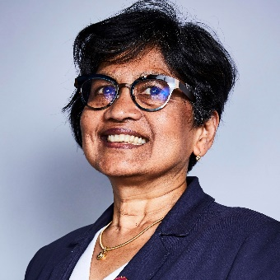
Image: Sue is wearing glasses and a dark blue blazer. She is smiling.

Employee shoutouts

Josh
We would like to recognise Josh for his continuous improvement in the Manufacturing department, particularly with his Snake Mesh welding. Josh has worked well on his punctuality, commitment to remaining at his workstation and always having a positive work outlook. We’re proud to have Empowered you to make some great Choices, Josh!
Image description: A smiling Josh bangs on a hand drum enthusiastically at the 2024 end of year party.

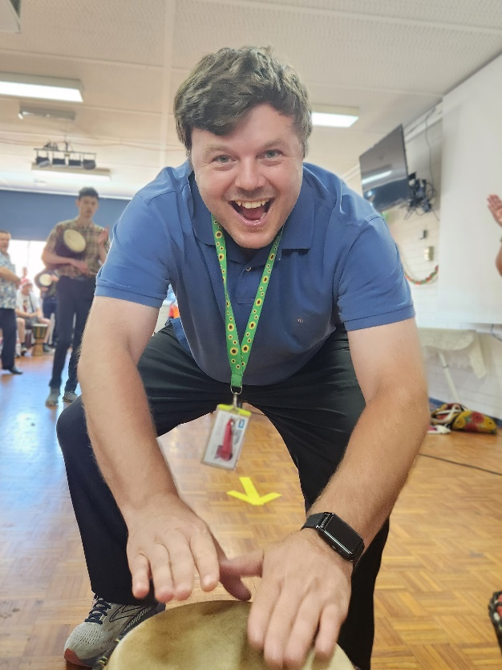

Wendy
We would like to congratulate Wendy for stepping up from her regular FLP job and learning a new task in a different job. Way to show you can be Adaptive, Wendy!
Image description: Wendy smiles proudly as she learns to use the paper shredder in the mailroom. Laura and George smile as they sit either side of her.
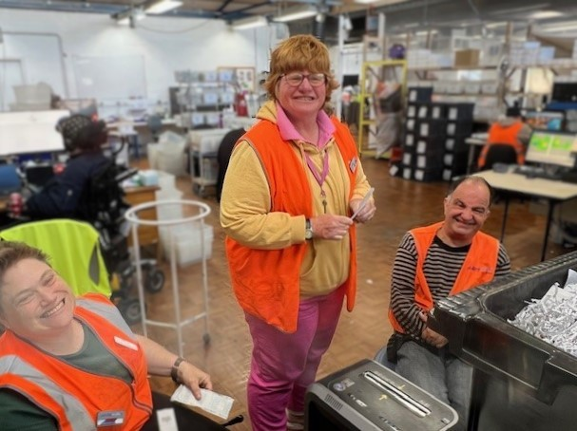

George
We would like to acknowledge the excellent job George has been doing in the Mailroom. Staying on task, following rules and excelling at his work on the robot. Great work at being Outcomes Focused, George!
Image description: George poses for a picture in the mail room while he works on the sorting robot.
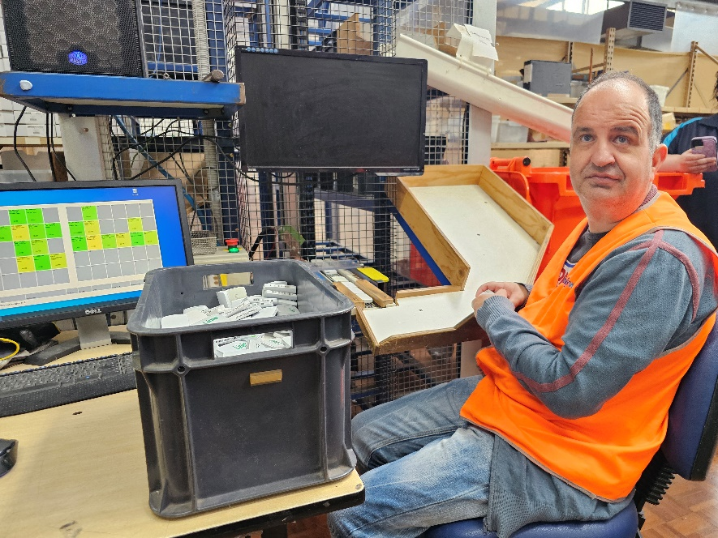

Spotlight
This quarter, we’d like to shine the light on a few employees that have been awarded a “Certificate of Achievement” and “Safety Worker of the Quarter.” Great work everyone!

Hanan
Awarded for staying focused on her task and paying attention to detail on the job.
Image description: Hanan proudly holds up her certificate in the lunchroom.
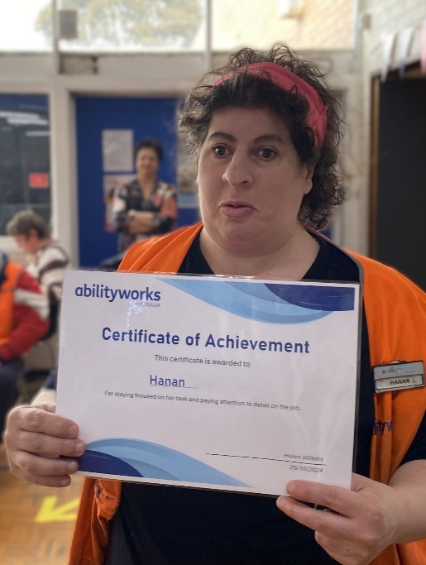

Warrick
Awarded for going into different departments and being open and willing to learn new skills and retrain on jobs.
Image description: A proud Warrick holds his certificate high, standing in the lunchroom.
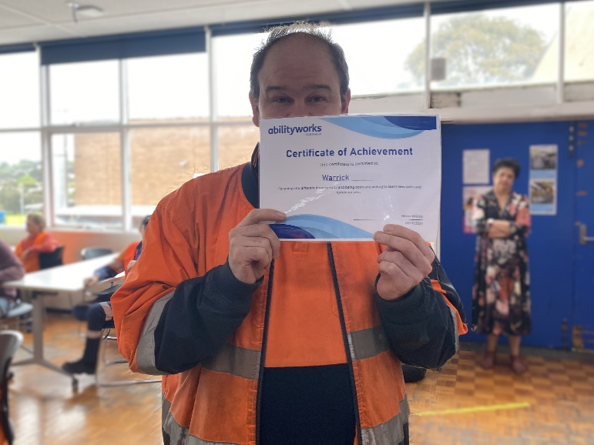

Daniel
Awarded for showing initiative to ask for training on new jobs and taking great pride in correcting and recognising mistakes.
Image description: Daniel smiles and holds up his certificate, Helen stands beside him, smiling.
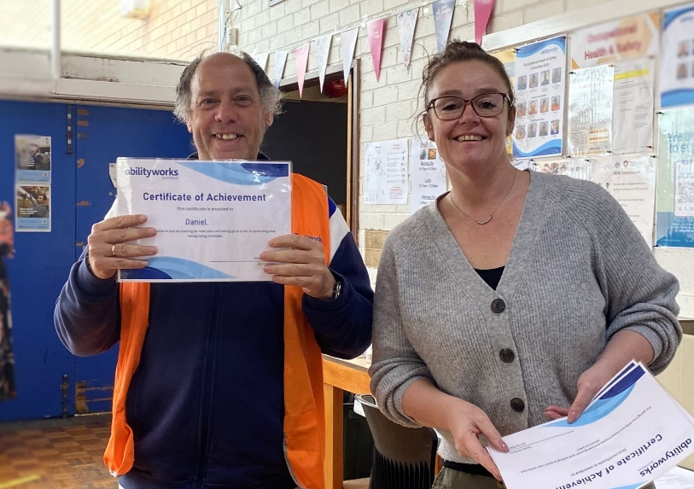

Sam
Awarded Safety Employee of the Quarter for always following and demonstrating workplace safety across all areas. Sam looks out for wellbeing of not only himself but also his co-workers. He humbly assists others and always displays a positive attitude within the workplace.
Image description: Sam proudly shows off his certificate and gift card in the lunchroom.
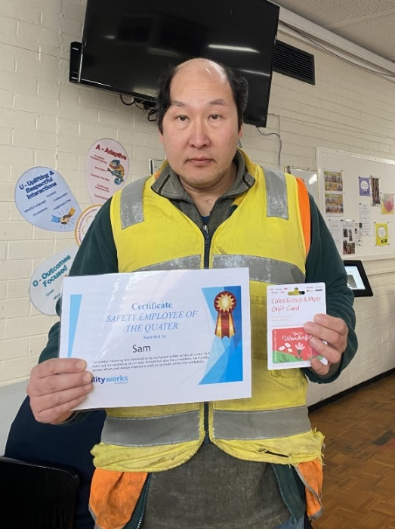

Around the building

Evacuation process
Do you know what to do if there is an evacuation?
When you hear the alarm:
- Walk calmly and quietly to the evacuation point
- Do not walk on the road
- The area warden will be wearing a YELLOW helmet and will check to make sure everyone has left the building
Image description: a bright yellow construction helmet.
- Wait quietly for the roll call at the evacuation point
- Answer clearly when your name is called
- Do not return to work until advised by the warden
- The chief warden will be wearing a RED helmet
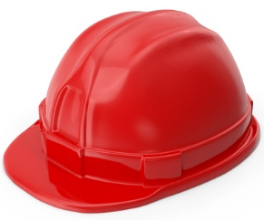 Image description: a bright red construction helmet.

Stairs
Until further notice, all employees are required to use the lift when moving between upstairs and downstairs as there is currently work being done to install electrical doors at the staircase. Thanks for your cooperation!

Expanding our inventory capacity: new pallet racking installation underway!
Exciting changes are happening behind the scenes! We’re boosting our inventory capacity with additional pallet racking in the rear storage shed, creating 60 new pallet locations to streamline our inventory management. This expansion strengthens our efficiency and opens doors for better service for our clients.
Expected Timeline:
Shed Repairs & Prep – David is already hard at work, welding the door track to ensure smooth access.
Component Delivery – Everything arrives on Friday, May 23, ready for installation.
Clearing Begins – Starting Thursday, May 22, we’ll begin reorganising the shed to make way for the new setup.
Installation Day – External contractors will get to work Monday, May 26 with expected completion in just one day, weather permitting!
Final Touches – On Tuesday, May 27, shelves will be labelled, and components placed in their new permanent homes.
If all goes to plan, this upgrade will be fully operational before this newsletter is published! Stay tuned for more updates as we build towards a more efficient and dynamic business model.
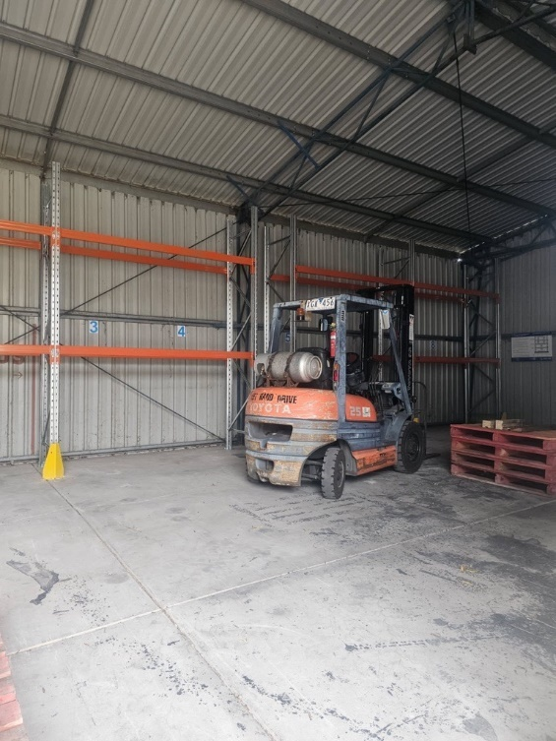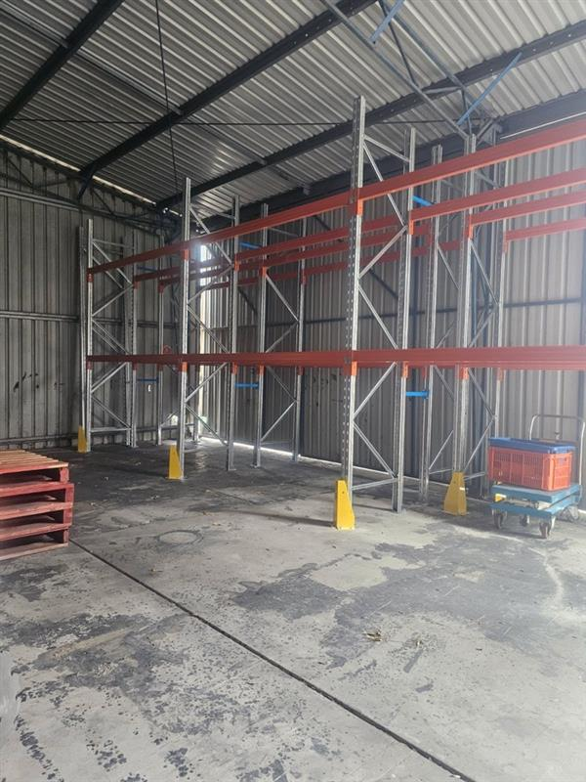
Image description: Two images show the progress of the pallet racking installation. The shed is bare, there is metal framing assembled, and a forklift sits to the side.

Workplace dress code and hygiene standards
At Ability Works, we want to ensure a professional, safe, and welcoming environment for everyone. To support this, we ask that everyone working at our facility follow our dress code and hygiene standards.

Dress code guidelines
- Clothing must be clean, well-maintained, and free from rips, tears, or holes, as these can pose a safety hazard (this includes ripped/frayed fashion).
- Attire should be neat, and appropriate for your work environment.
For example:
  - Full length pants must be worn in the manufacturing department.
  - Hi-vis vests are required in all production and manufacturing areas.
  - Skirts, dresses, oversized clothing or anything made with excessive fabric (i.e. flowy wide leg pants) could present a safety risk across all departments.
- Identification badges must always be worn to ensure workplace security.
- Where required, personal protective equipment (PPE) must be worn (this is typically any production/manufacturing area).

Footwear
- Enclosed shoes are required to ensure workplace safety.
- Footwear should be clean, in good condition, and appropriate for your role.
- Some areas may require steel-capped safety shoes for extra protection.

Jewellery
- Jewellery should be minimal and non-intrusive to prevent safety risks. Avoid dangling earrings, sharp jewellery, or exposed necklaces.
- If a piece of jewellery poses a safety concern, management may request its removal.

Personal hygiene
- Maintaining good hygiene helps create a comfortable and respectful workplace.
- Please avoid strong odours, including cigarette smoke and excessive body spray/perfume.
- Hair should be clean and well-groomed, and long hair must be tied back for safety.

Can you correctly identify all of Molly’s choices?
Try circling all the correct style choices and crossing out all the wrong choices.
If you’re accessing this document with screen-reader assistance, listen for the image descriptions – anything that may be worth noting has been mentioned, so you can play along too!
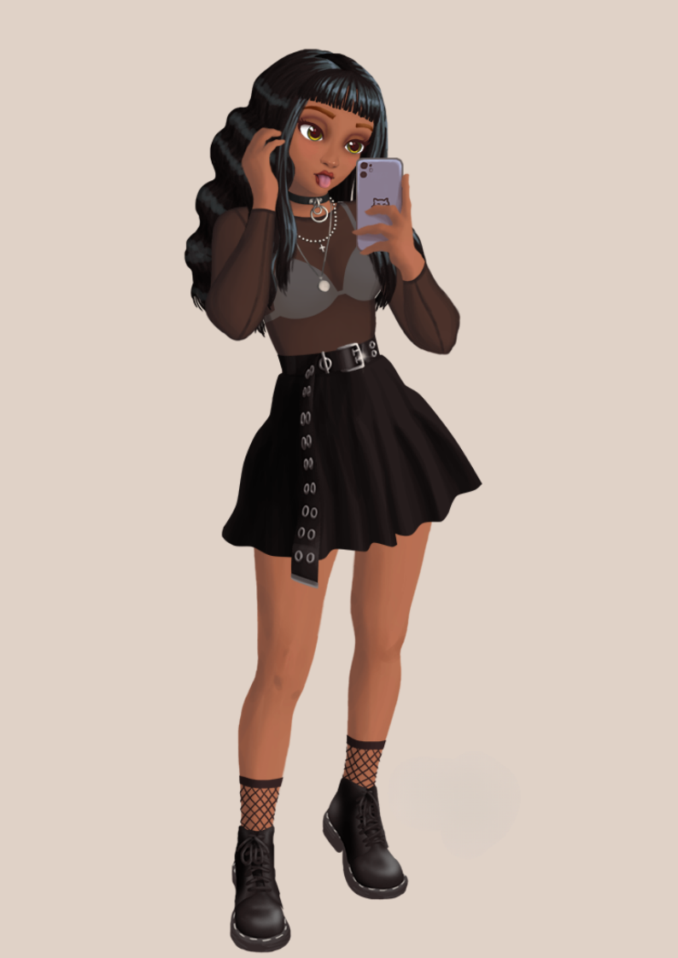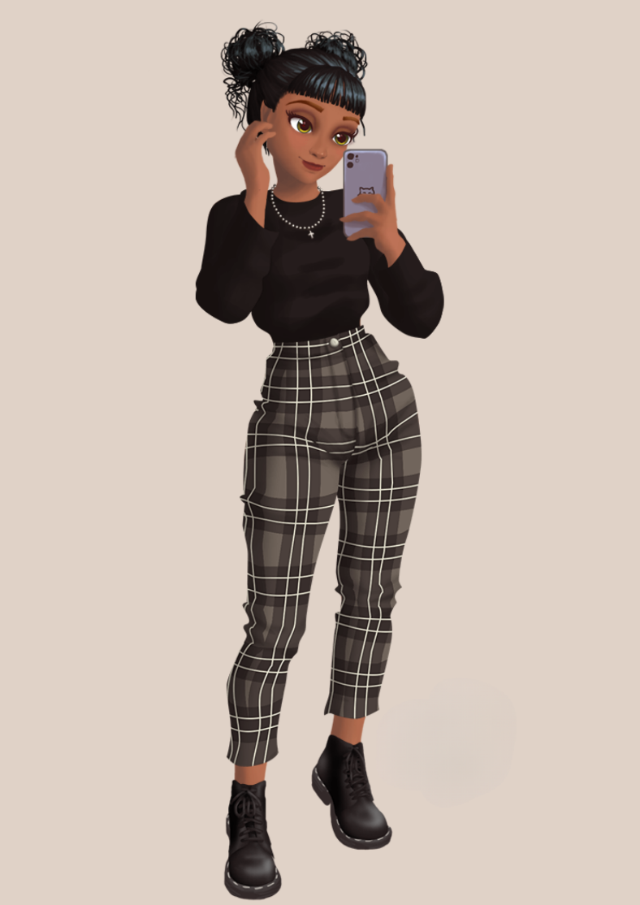
Image description: Two cartoon images of a young woman show her two different outfit choices.
On the left, she wears her dark wavy hair loose, she has a cluster of necklaces on, and her shirt is made of a sheer mesh. She has a long belt hanging from her waist and is wearing a short skirt along with fishnet socks.
To the right, she wears a well fitted sweater and plaid pattern pants. She is wearing black boots, a simple, single necklace, and her hair is tied up into two messy buns.

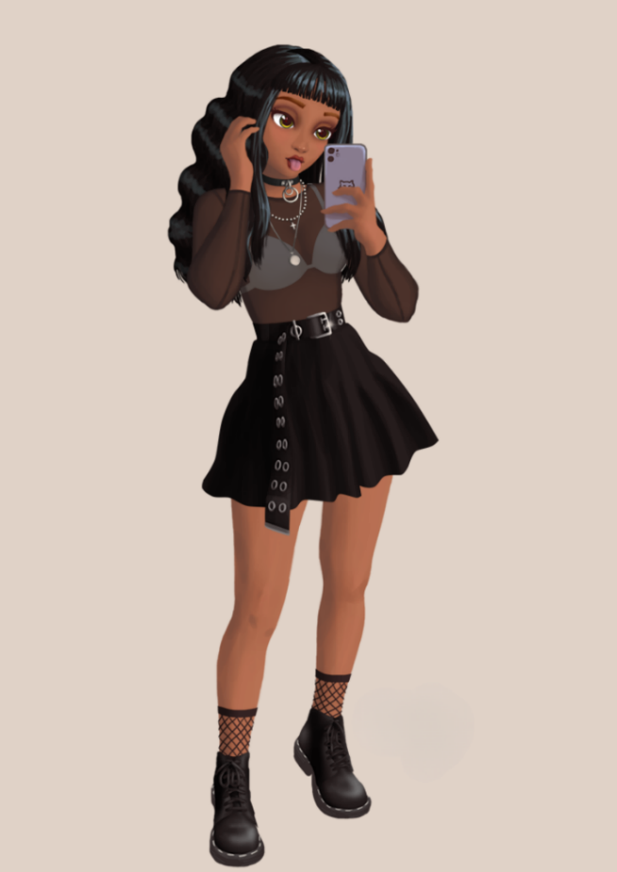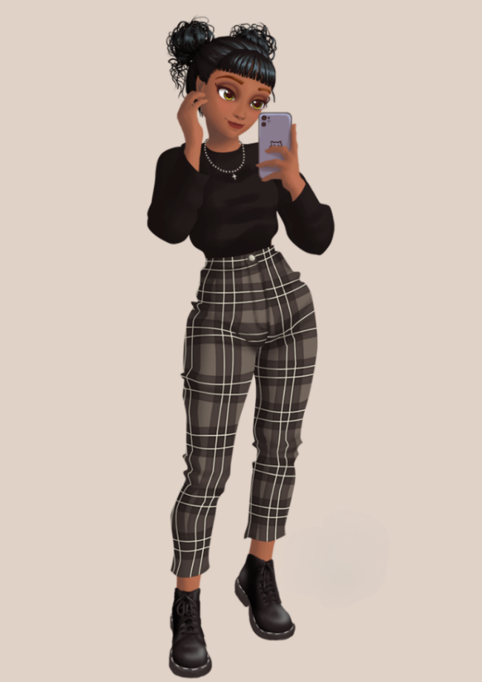
Image description: Two cartoon images of a young woman show her two different outfit choices. There are crosses and circles drawn over the image to highlight the right and wrong fashion choices described below.
Almost all of Molly’s outfit choices on the left are unsuitable for the workplace, especially one with machinery. Her long, wavy hair should be tied back to prevent it from getting caught, and she’s wearing too many necklaces, which could pose a safety hazard. The sheer shirt is impractical, and her long belt and flowing skirt could easily get snagged on equipment or objects around the building. Her fishnet socks with holes also add to the risks. The only well-chosen item in this outfit is her closed-toe boots.
On the right, however, Molly’s choices are much safer and more practical. Her clothing fits well, doesn’t reveal her underwear or expose too much skin, and avoids any loose fabric that could catch on machinery. She’s wearing a single necklace that sits close to her neck, making it less of a risk. Her hair is neatly pulled back, keeping it out of the way. And she’s still wearing the same boots, because the program I used didn’t have many shoe options, ha ha!
How did you do?

A visit from Transurban

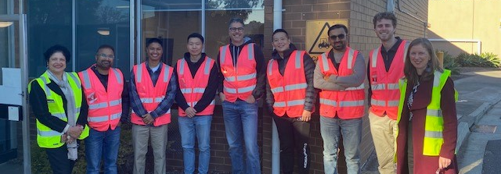
Image description: A group of seven Transurban team members stand outside the Ability Works office with AWA staff, Anu and Alana. Everyone is smiling and wearing bright hi-vis vests.
Ability Works Australia was delighted to host Transurban’s Digital Optimisation team for their corporate volunteering day on Monday, 19 May.
As long-term partners, Ability Works Australia proudly manages Transurban’s national mailroom. On the day, the Transurban team immersed themselves in our operations, shadowing employees across various business units, including packing and assembly, wire and metal manufacturing, and documentation management.
Following their experience, the team (pictured above) shared these reflections:
“I felt enriched and inspired.”
“The day broadened my horizons about the capabilities of social enterprises like Ability Works Australia.”
“I was impressed with how the Ability Works Australia employees delivered complex work with such precision.”
“I was so touched to see how much the employees love working at Ability Works Australia”

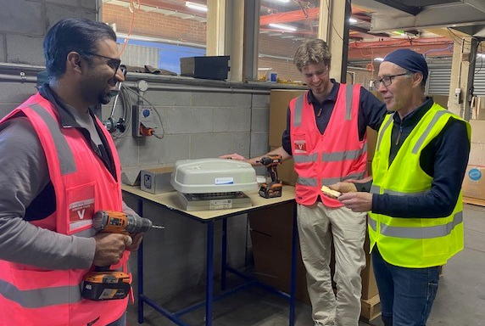
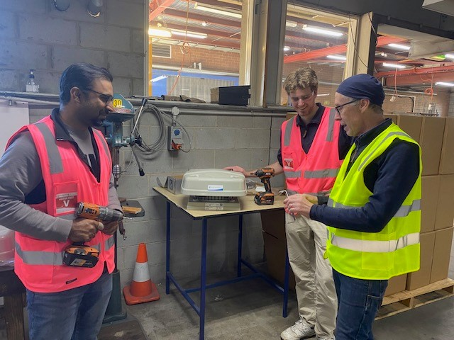
Image description: Two images show Jackson and Hasan from Transurban’s Digital Team learn about our work in assembling HVAC units from Andrew, Senior Supervisor of Manufacturing.

Painting of cooling fan clutch kits for Norman G Clark
We’re excited to be trialling a new project with our long-time commercial partner, Norman G Clark – painting cooling fan clutch kits that are used in Kenworth trucks.
Recently, Peter from Norman G Clark visited our site to train our team on the painting process. By the end of the day, our employees had successfully completed 80 kits – a fantastic result!
A big shout-out to David, our toolmaker, who designed a special jig and safety process that allows one kit to dry while another is being painted. It’s helped make the process smooth, safe, and efficient.
We’re proud to work with partners like Norman G Clark, whose values truly align with our mission to create meaningful employment for people with disabilities.
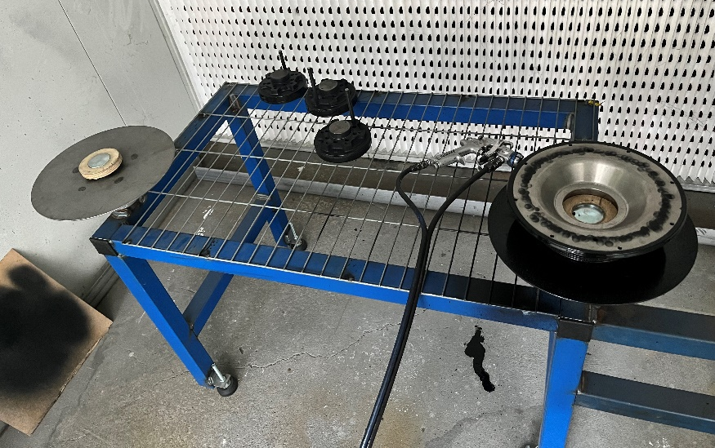
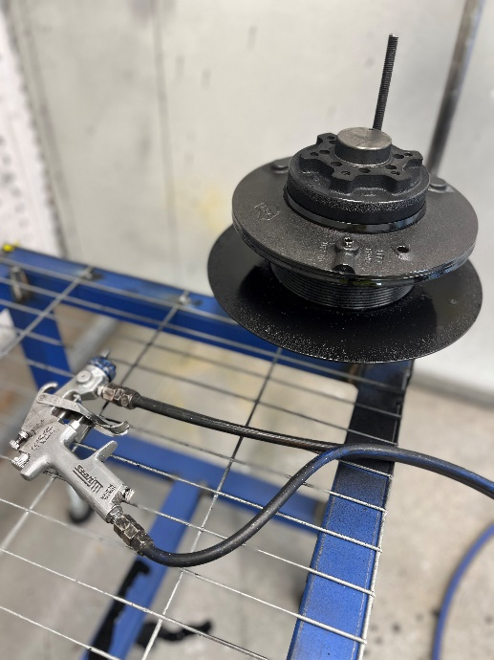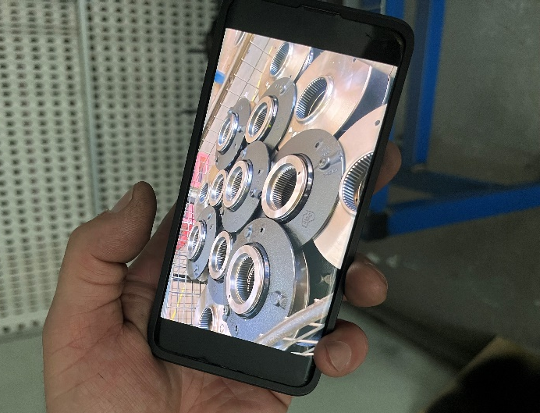
Image description: A group of three images showcase a blue and silver metal frame that allows employees to paint and dry two fan clutch kits at the same time.

Updates from the Employee Representative Committee (ERC)

2025 Employee Representative Committee
Dear employees, families and carers,
It is with much excitement that we announce Ability Works Australia, Employee Representative Committee (ERC) for 2025.
First, we’d like to acknowledge the valuable contributions of the 2024 committee and express gratitude for their passionate and diligent support of all employees - not to mention the high level of commitment to making Ability Works Australia a great place to work. They are Ruby (President) Laura (Secretary), Philip, Ken, Ebony, Neil – also acknowledgement of James and John who were unable to complete their term due to conflicting commitments.
Congratulations to Ruby, Mark, Ben, Ken, Greg, Mark, Hanan and Laura, who have been nominated and elected to represent the committee for 2025. Further, Mark has been elected to the role of President and Ruby will be holding the position of Secretary for this term.
We’d also like to recognise the many other employees who were so enthusiastically nominated by their peers.
Dates for 2025 ERC meetings are: THURSDAY 27 March, 17 April, 15 May, 19 June, 17 July, 21 August, 18 September, 16 October, 20 November, February 2025 (TBA) from 1pm until 2.45pm.
Personally, I'm very grateful and proud to be continuing in the role of Advocate for the ERC, welcoming questions and suggestions to ensure continued effectiveness and professionalism from Ability Works Australia, Employee Representative Committee.

Rae Bonney OAM
Manager Mental Health, Wellbeing & Support

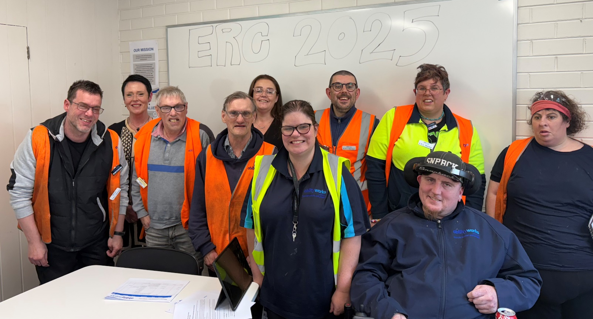
Image description: The 2025 ERC committee gather together in the boardroom, seen left to right – Mark, Rae, Greg, Ken, Helen, Ruby, Ben, Laura, Mark, Hanan.

ERC president report
Hello and welcome to the second president report for the ERC, 2025.
In Manufacturing this quarter we've been working away at our coil holders - both large and small -, Abey nut welding is trucking along nicely, and screw caps continue to work away at the quota for the quarter.
In the Mailroom, even with a few down days, we're tracking to make target for the quarter. Mail continues to come in for processing, both with and without correspondence - keeping everyone in the team skilfully employed
In Packing and Assembly this quarter we've been working away at our FLP and ModWood figures, along with CPAP sleep kits. We're also currently producing fillet strips.

Regards,
Mark Golotta,
ERC President.

Inclusive Design

Validating Ability Works core values through focus group research
At Ability Works, our values shape the way we connect, collaborate, and contribute as a team. However, concerns arose regarding whether these core values were truly understood and embodied by our employees. To address this, the Inclusive Design team conducted a focus group to explore effective ways to communicate these values visually and meaningfully throughout our workplace.

Identifying the challenge
It became clear that the company’s core values needed to be reinforced to ensure clarity and alignment. The Inclusive Design team invited a diverse group of employees - representing various genders, ages, and comprehension levels - to participate in a focus group. The goal was to brainstorm how to display these values prominently around the building and make them relatable and memorable.

Engaging through research
Facilitated by team members Natalie, Dom, and Morgan, the focus group included presentations and discussions to spark ideas and gather insights. Participants reviewed the current value descriptions, examples of how the values were practiced, synonymous words or phrases, and the imagery associated with each value.
Their feedback uncovered which visuals resonated most, which values were well understood, and where improvements could be made.

What we learned
The focus group yielded positive results overall:
- Four of the five core values were well-received, with participants drawing clear connections between the imagery and the intended meaning.
- Cartoon-style visuals stood out as favourites due to their vibrant colours and direct representations, though the icon-based designs also garnered praise.
However, room for growth was identified:
- The "Empowering Choice" imagery sparked debate, as the crossroads cartoon symbol was perceived as representing indecision rather than empowerment. While there were little alternative suggestions, this value’s visual representation may require revision.
- Participants found it challenging to provide examples for “Uplifting and Respectful Interactions,” despite demonstrating an understanding of the concept through associated keywords.
- For “Outcomes Focused,” participants gave examples showing comprehension but suggested supporting words that were tangential rather than direct matches. This highlighted the need for clearer associations.

The outcome

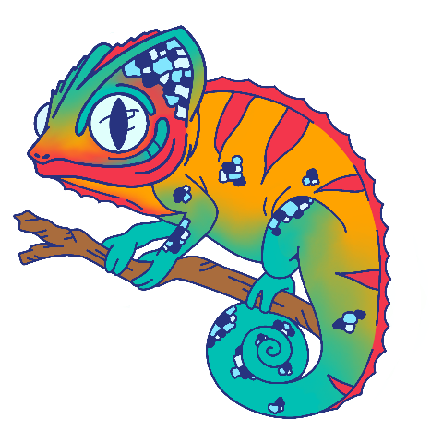
Adaptive
Proactive problem-solving and continuous improvement.
- Flexible, Responsive to change, Proactive problem solving
“We have a toolmaker that adapts machinery to suit our needs.”
Image description: A colourful chameleon is perched on a branch. Depicting adaptability through its colour-changing scales.

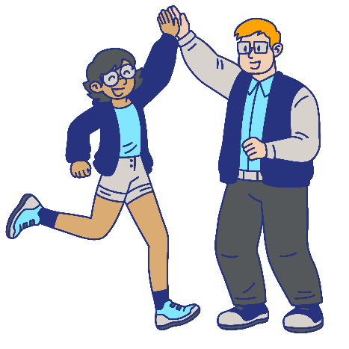
Empowering choice
Promoting autonomy and ownership of work decisions.
- Encouraging potential, Taking responsibility, Nurturing individuality
“We empower choice with Independent Employment Plans (IEPs) and regular reviews.”
Image description: Two people hi-five enthusiastically. Empowering one another to make their own choices.

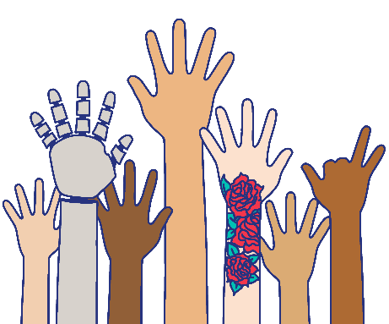
Inclusive
Equal opportunities for growth and decision-making.
- Everyone equal, Open minded, Diverse
“We encourage employees to be included in groups, like the Occupational Health and Safety (OHS) committee.”
Image description: A diverse group of hands reach upward. Inclusivity is represented by each individual hand, one missing fingers, one prosthetic, one tattooed with roses, and all different shades of skin.

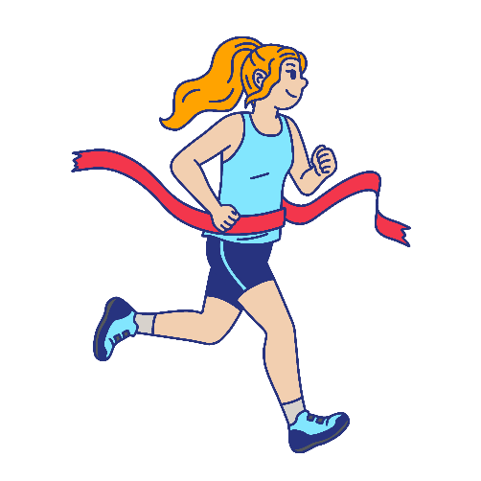
Outcomes focused
Role clarity and measurable decisions.
- Making targets, Reaching goals, Practicing accountability
“We focus on outcomes by setting production goals and encouraging everyone to meet them.”
Image description: A runner approaches the finish line of their race by being focused on their outcome to achieve their goal.

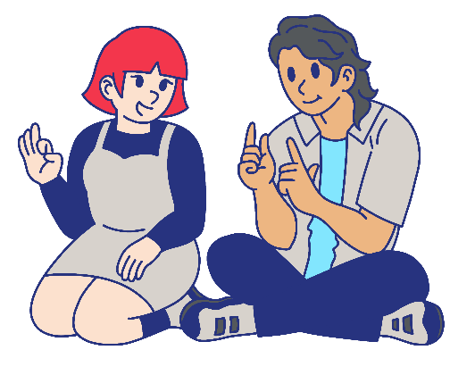
Uplifting and respectful interactions
Encouraging respectful communication and preventing discrimination.
- Acceptance, Collaboration, Thoughtful communication
“We foster uplifting and respectful interactions by implementing tools like an inclusive language guide.”
Image description: Two people engage in cheerful AUSLAN communication. Demonstrating uplifting and respectful interactions by communicating in their mutually understood format.

Next steps
Updates to wording and imagery have been made, and posters are in the process of being developed.
The Inclusive Design team recommends introducing these core values verbally during toolbox meetings. This approach will facilitate interactive discussions and ensure employees feel engaged as the new posters are displayed around the building.
By validating our core values through collaboration and inclusivity, Ability Works continues to empower choice, uplift interactions, and focus on outcomes - all while fostering a respectful and supportive workplace culture.

Ability Works partners with Alstom for human-centered design testing on Next Generation Trams
As part of the billion-dollar Victorian Transport project awarded to Alstom, Ability Works has proudly contributed to the design and manufacturing of 100 G-Class trams for Melbourne. This significant project included conducting human factors testing on the digital passenger information display screens.
28 individuals were recruited by Ability Works, representing diverse disabilities and human experiences to evaluate the usability and accessibility of the digital passenger information screens on the new G-Class trams.
Participants engaged in a simulated journey from Melbourne Central Station to the Royal Melbourne Hospital, interacting with the digital screens and providing feedback on their clarity and ease of use.
During the testing, participants assessed how effectively the screens conveyed tram routes, stops, and other travel information. This feedback is crucial for ensuring that the trams are accessible to all passengers, including those using mobility aids.
The insights gathered from this user testing will enable Alstom to refine and enhance the digital passenger information experience on their Next Generation Trams, making public transport more inclusive and user-friendly for everyone.
Ability Works is honored to be part of this transformative project, contributing to a more accessible and efficient public transport system in Melbourne.
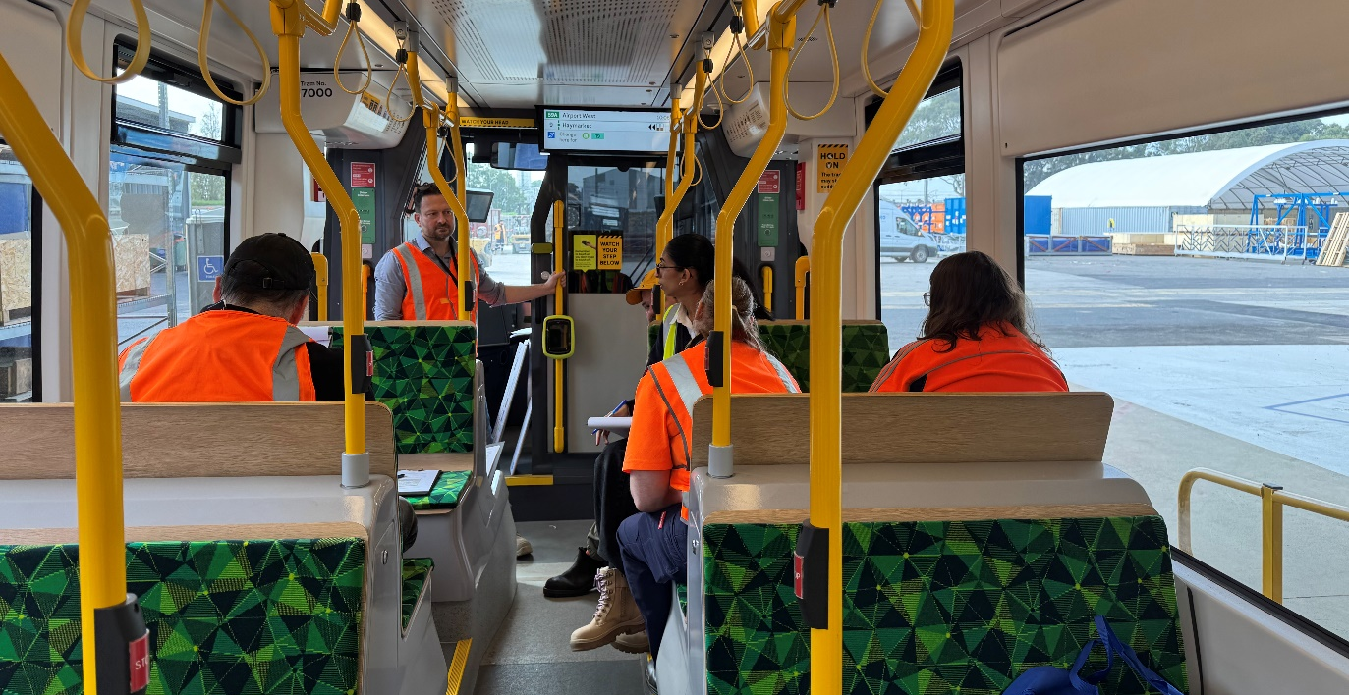
Image description: Interior view of a Next Generation Tram mock-up. People are sitting and standing in the tram, engaged in discussion.

Accessibility for non-profit organisations: Technology for Social Justice Conference 2025
Ability Works, as an OZeWAI member, conducted a practical masterclass workshop at the InfoXchange, Technology for Social Justice conference held at The Telstra Insights Centre on May 8, 2025.
The Inclusive Design team facilitated a one-hour workshop about digital accessibility and inclusive communication. In the session, audience observed live demonstrations and participated in testing and group discussions. They learned how different people experience digital content. Everyone left with resources they could take back to their organisations to help make websites, documents and communications easier to use and more accessible for everyone.
Our presentation began by introducing Ability Works and sharing Dominique’s experience with hearing loss and the accommodations and tools he uses such as a sign language interpreter, captions for videos and time to review meeting recordings, to show how accessible communication and ways of working help him do his job working as a user researcher. Next, we looked at simple ways to make content more inclusive. This included:
- applying good colour contrast,
- adding captions, transcripts and sign language to videos,
- making sure images have alternative, descriptive text,
- using clear, structured headings,
- explanatory link text,
- easy to read hashtags with camel case (#DigitalAccessibility),
- readable fonts,
- making sure content works with a keyboard, and,
- why PDFs should also be accessible.
We shared the importance of co-design and usability testing, working with people who have lived experience to make sure communication works well for everyone. These easy steps help more people, especially those with disabilities, use digital content. It also helps build a fairer and more inclusive society.
Ability Works is a member of OZeWAI, The Australian Web Accessibility Initiative. OZeWAI is a volunteer-run professional association dedicated to supporting digital accessibility professionals in Australia. Ability Works regularly supports and contributes to OZeWAI events and in return members of our team receive important digital accessibility mentoring and skills development.

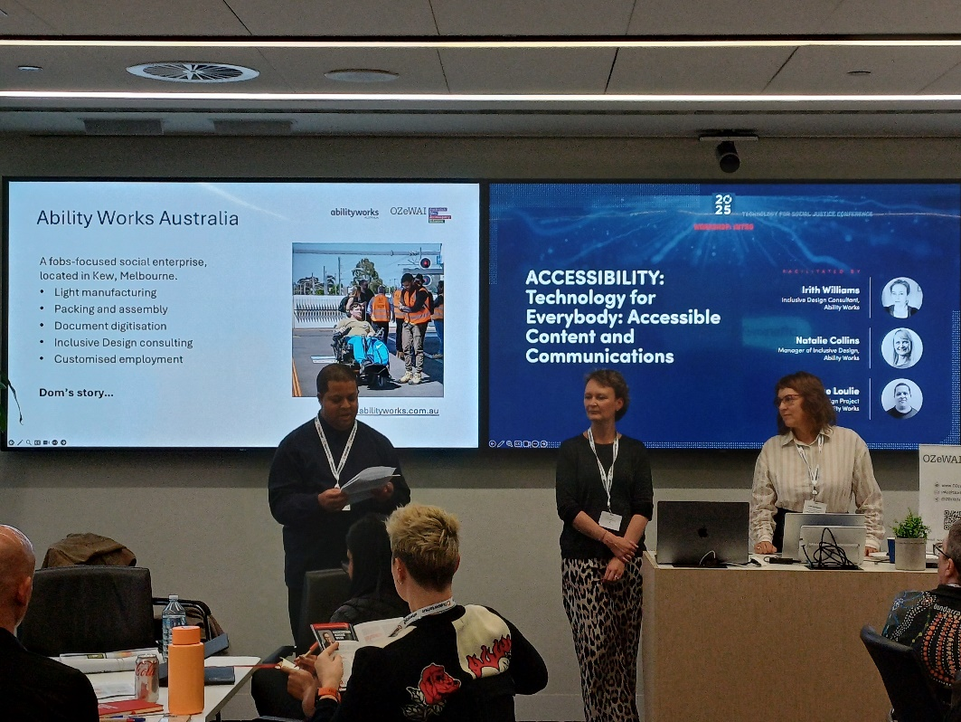
Image description: Three people (1 male and 2 women) are standing in front of seated people. The male is reading from a paper, with a screen behind them with the words, ‘Ability Works Australia’, and the title on the second screen, ‘Accessibility: Technology for everybody: Accessible Content and Communications’.
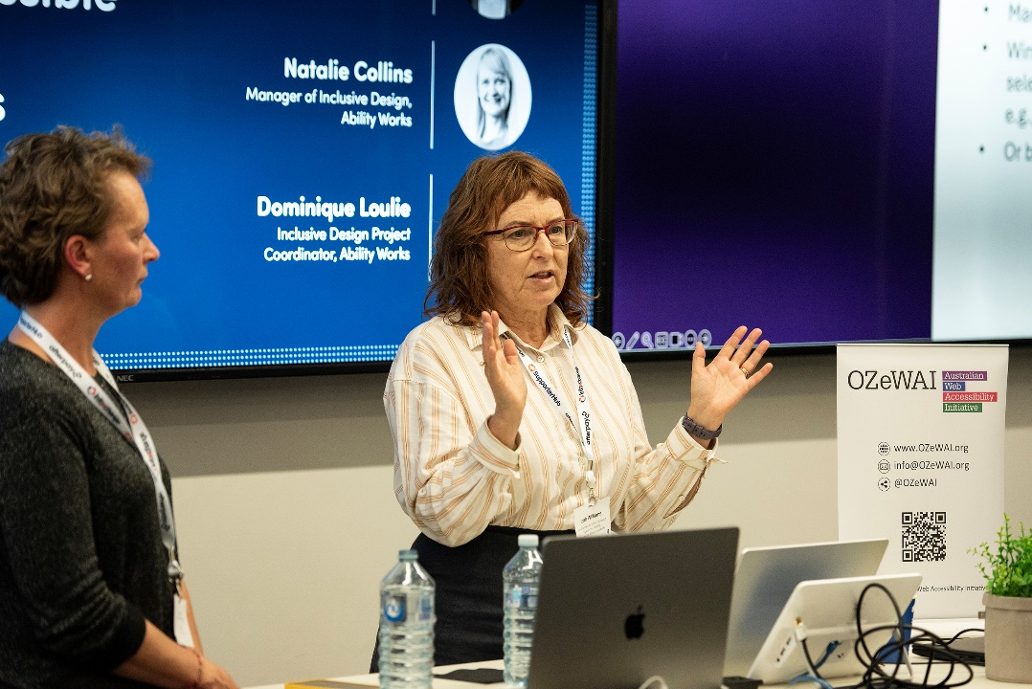
Image description: A woman with dark brown hair stands in front of computers with her hands splayed in front, with another woman with short hair watching from the left side with an audio-visual screen behind. The words visible are, “Natalie Collins, Manager of Inclusive Design, Ability Works”, and “Dominique Loulie, Inclusive Design Project Coordinator, Ability Works”.

Customised Employment

Participant acknowledgement
We’d like to recognise one of our Customised Employment participants for not only obtaining employment but being featured in the company’s newsletter as “Team Member of the Month”. Way to go Jayden!
We’ve included a copy of the article below:
“In just over six months, Jayden has become a bit of a legend around here, developing a ‘cult status’ amongst his fellow team members! Coming to us through Ability Works – a fantastic non-profit that helps match people with meaningful, customised work – Jayden has quickly made his mark.
When asked about his time at IVE, Jayden says “I love working here! I really enjoy the work. I really like working with the people who have been very patient (and supportive) with me – especially Alan, Joshy, Gary and Mick.”
Jayden has been a powerhouse on the cutting tables, helping out in the finishing area, moving pallets, feeding sheets into the Zund, and even championing our sustainability efforts by keeping waste management on point. He’s also gearing up to put his brand-new forklift licence to good use!
Outside of work, Jayden is a dedicated basketball player for the Doncaster Warriors and loves hanging out with his mates.”
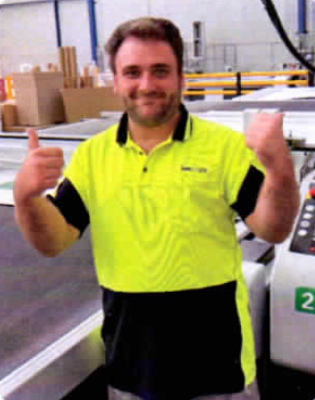
Image description: Jayden smiles wide, with two thumbs up. He is wearing yellow hi-vis and appears to be in a warehouse.

Employee input

Luke and Michael Pena
In December 2024 we were fortunate to have a visit from Michael Pena (an American actor) at Ability Works.
He was filming a TV series at the Royal Talbot hospital, and Luke was lucky enough to meet him. Michael has starred in Fury, 12 Strong, Tom & Jerry and Fantasy Island.
Editors comment:
As Morgan was putting this newsletter together, she finally realised who Michael Pena is, and is envious of Luke right now - he’s that guy in Ant Man that takes forever to tell a story that should have only taken him five seconds! He’s the best!
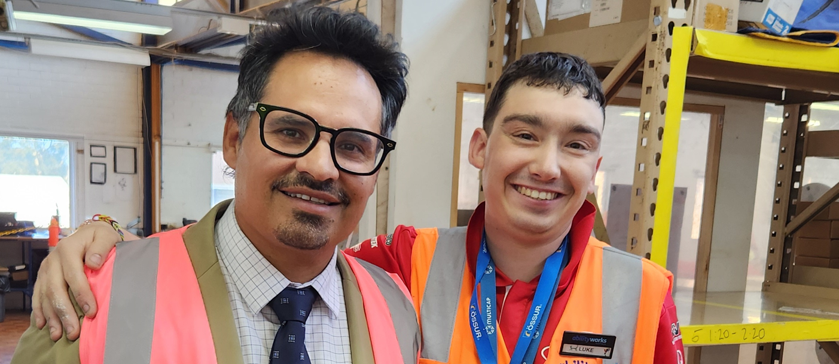
Image description: Michael Pena stands on the left, wearing black rimmed glasses, with Luke on the right, arm wrapped around Michael’s shoulder. Both are smiling cheerfully.

Cooking with Jimmy - tuna and egg quick meal

Ingredients:
- 1 onion peeled and diced to maintain some chunkiness (to get no tears, cut under fume hood or ask someone else to do it)
- 2 eggs
- 1 large tin tuna in oil (Jimmy chose chilli flavour. and it wasn’t spicy enough, but Jimmy didn’t write a letter)
- 1 tsp. salt
- black pepper x enough (not too much)
- dried oregano x enough (not too much)
- olive oil x “a bit” in pan
- mozzarella cheese x enough, to cover all with thin layer, melted
- 1 handsome tsp. garlic powder or a finely sliced or diced large clove

Method:
- peel and dice the onion, then place into medium to large frying pan with a lil olive oil, heat on medium heat until semi-wilted (can do this on low heat to allow time for the remaining prep)
- get a large mixing bowl
- empty the tin of tuna and a decent fraction of the oil from the tin into mixing bowl
- crack both eggs into the bowl give a mixy-whisk, but don’t stress, we are not making a cake, we just aim to combine tuna chunks and eggs evenly
- measure the garlic powder or dice or fine slice the fresh peeled garlic clove and stir into tuna and egg in bowl
- add the measured salt, black pepper and dried oregano - stir into tuna in bowl
- pour chunky oily gloopy, now seasoned, tuna mix into pan with semi fried onion
- spread the tuna onion and egg mix out so it covers base of pan and integrates evenly with the onion
- get your cheese grater and grate sufficient Mozzarella cheese over what’s in pan until there is a nice cheesy layer ready to melt on top
- when cheesy layer melted be cautious of heat, so I think let rest a mo maybe while you turn some bread into toast to support this dish - that’s what I did it was rather noice
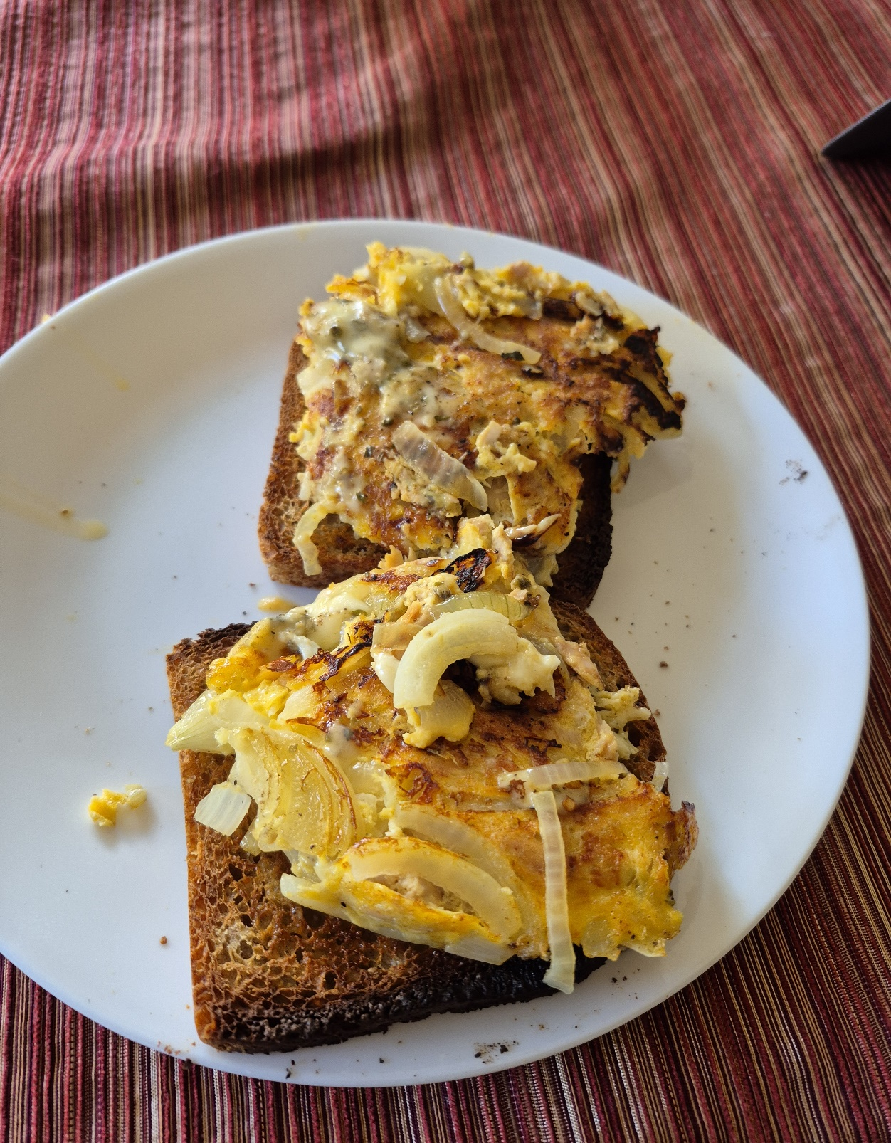

Image description: Jimmys delicious dish of egg, tuna and toast, presented on a white plate, atop a red stripey tablecloth.

Dish inspiration from: https://youtube.com/shorts/vggdtWCxuZQ?si=dXi2VjirGVICt2aa

Signed – jimmyNang (I mean Jimmy Baker)

Warrick
Warrick went to “Harry Potter: The Exhibition” in Melbourne, on Monday, May 19. He liked how they all dressed up, he had heaps of fun, and said, “It was amazing”. It’s on now at Fever Exhibition and Experience Centre - Melbourne 62 Dawson Street. The venue is wheelchair accessible.
Image description: Warrick stands in front of a bright red Hogwarts train as it blows clouds of smoke.
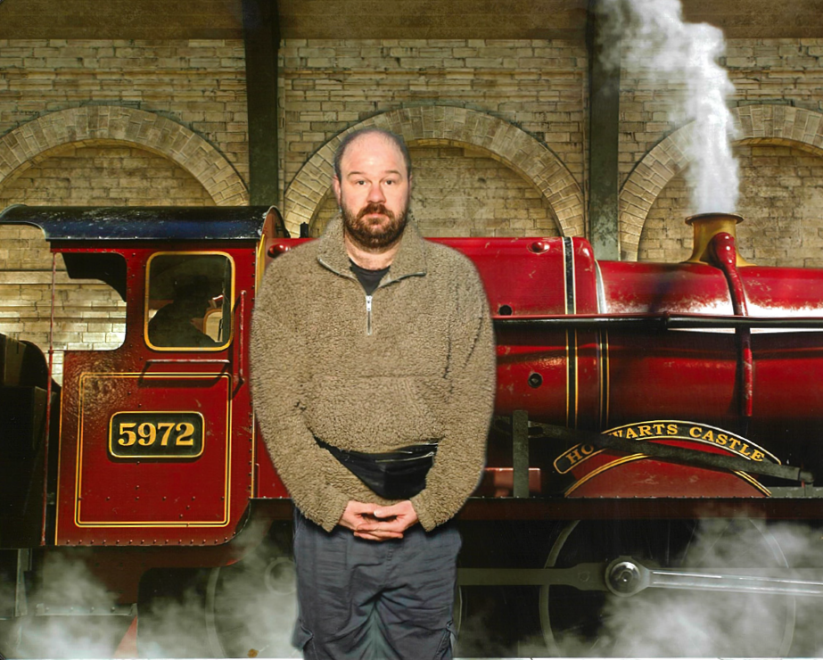

Ben and Laura
Ben and Laura celebrated their anniversary in March with a trip to Echuca. They’ve sent us a few photos from their trip to share with everyone.
Image description: A collection of photos show Ben and Laura enjoying their getaway. They eat lots of yummy food, pose cheerfully in front of signs for ‘The Mill’ Food, Bar, and Lounge, and the Port of Echuca. Their smiles shine as they raise their drinks in a toast aboard a riverboat, while another snapshot shows them enjoying the lively atmosphere near a water park.
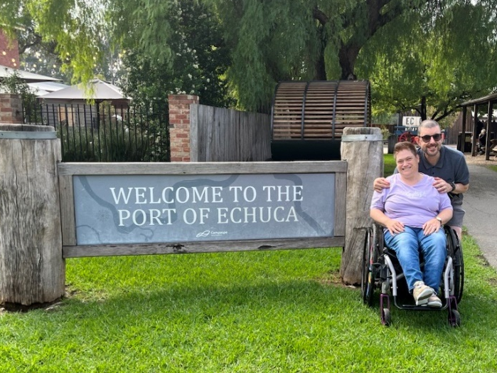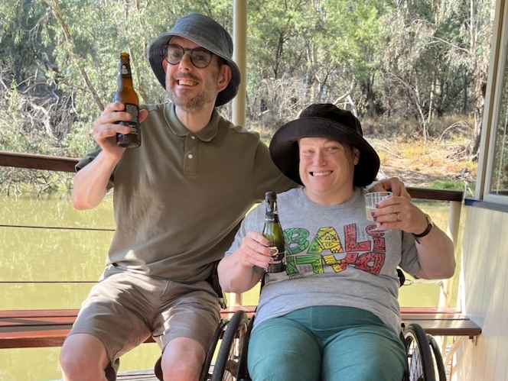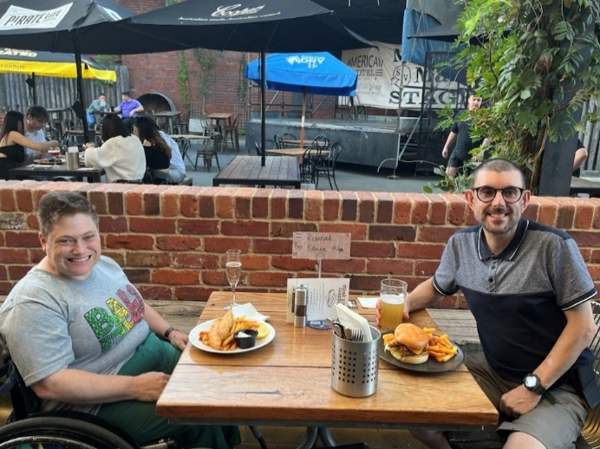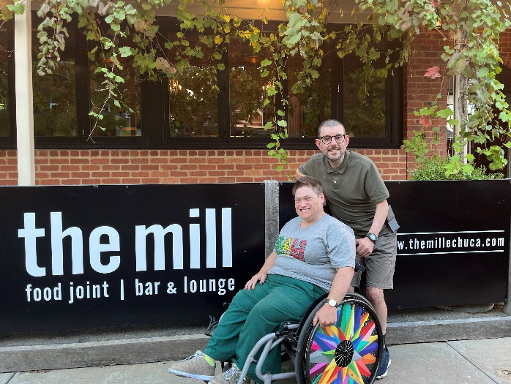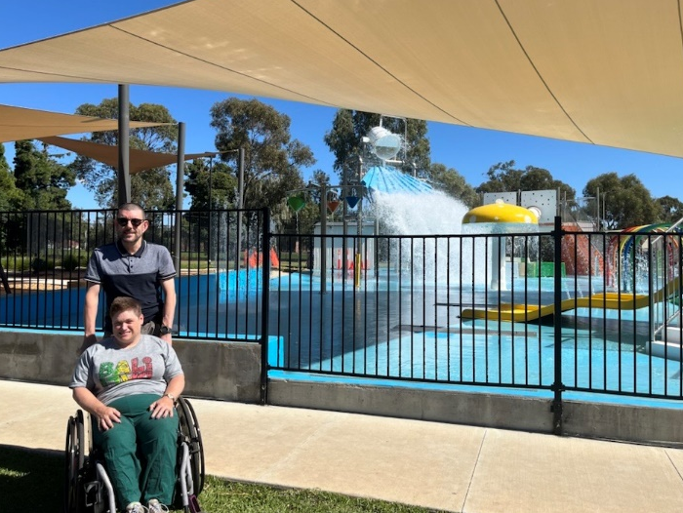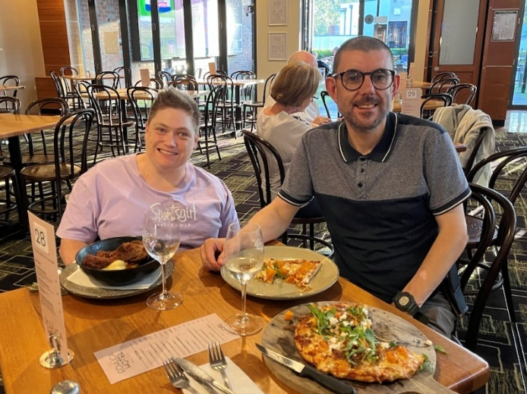

Jared
Image description: Jared poses for a photo with his first-place ribbon for bowling.
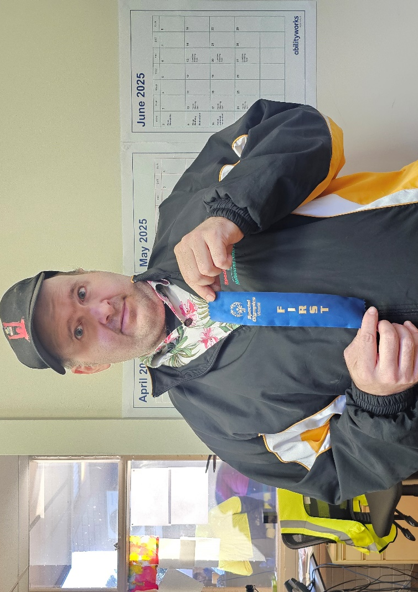

Luke
Image description: A cheerfully proud Luke shows off his three first place and one third place prize ribbons for his swimming.
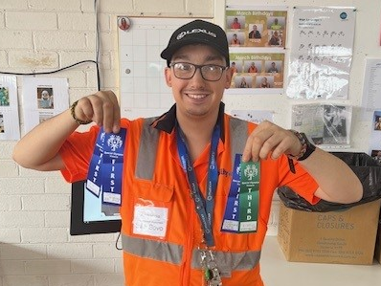

Activities

Crossword – the theme is “accessibility”
(Clues are on the next page )
Type the following link into your web browser for a digitally accessible version of this crossword: https://crosswordlabs.com/view/accessibility-42

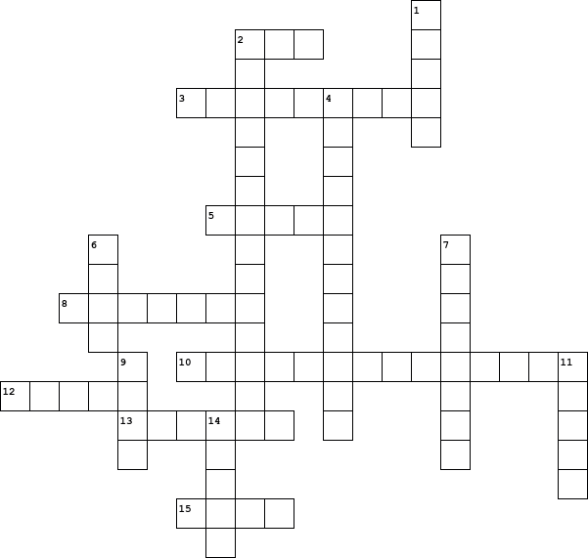

  Across
  2. | Help provided to those in need.
  3. | Creating spaces where all individuals feel valued, welcomed, and supported
  5. | Speech or sound used for communication.
  8. | Descriptive text for images to aid visually impaired users.
  10. | Text displayed on a screen to help those who are hard of hearing.
  12. | Someone or something that leads.
  13. | Ability to use or enter a space or service.
  15. | Free from harm or obstacles.
  Down
  1. | A visual impairment.
  2. | Adjustments or modifications to ensure equal opportunities for people with disabilities.
  4. | Software converting text to speech for the visually impaired
  6. | Assistance or support.
  7. | Term describing technologies or strategies that modify to meet specific needs
  9. | A hearing impairment.
  11. | Visual or physical cues for communication.
  14. | Same for everyone, without bias.

Riddles
Riddle 1: What must be broken before you can use it?
Riddle 2: What is full of holes but still holds water?
Riddle 3: David’s parents have three sons: Snap, Crackle, and what’s the name of the third son?
Riddle 4: What invention lets you look right through a wall?
Riddle 5: What has hands, but can’t clap?

Answer 1: An egg
Answer 2: A sponge
Answer 3: David
Answer 4: A window
Answer 5: A clock

Photo gallery
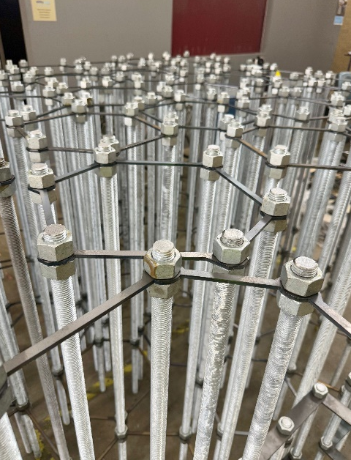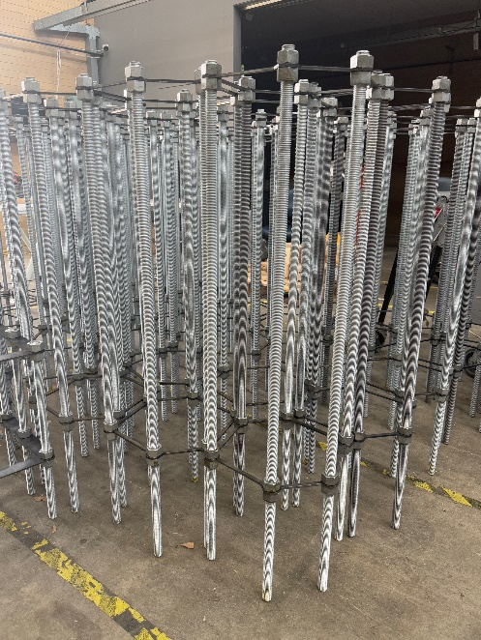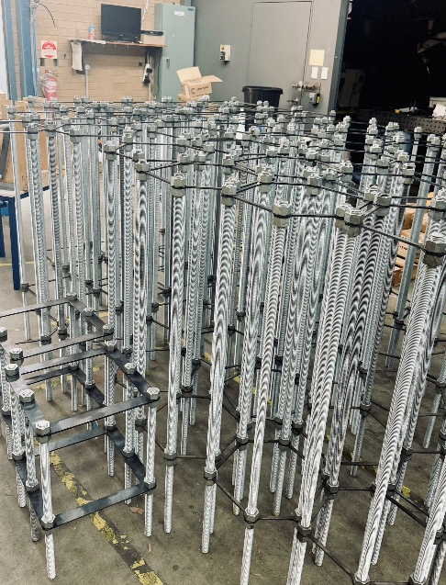
Image description: Three images showcase recent bolt assembly work done in our Manufacturing department.
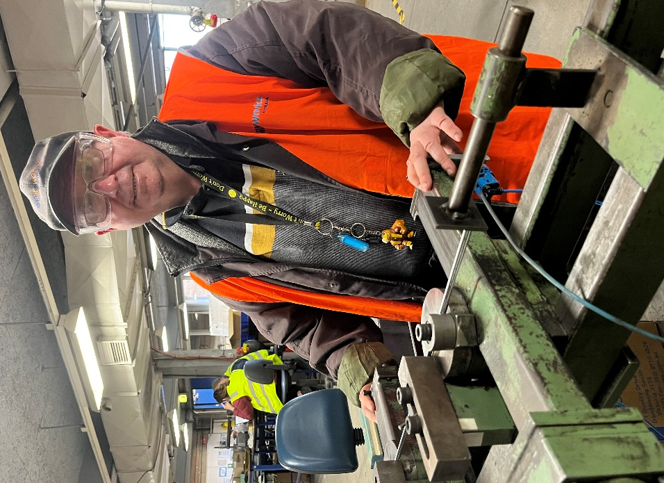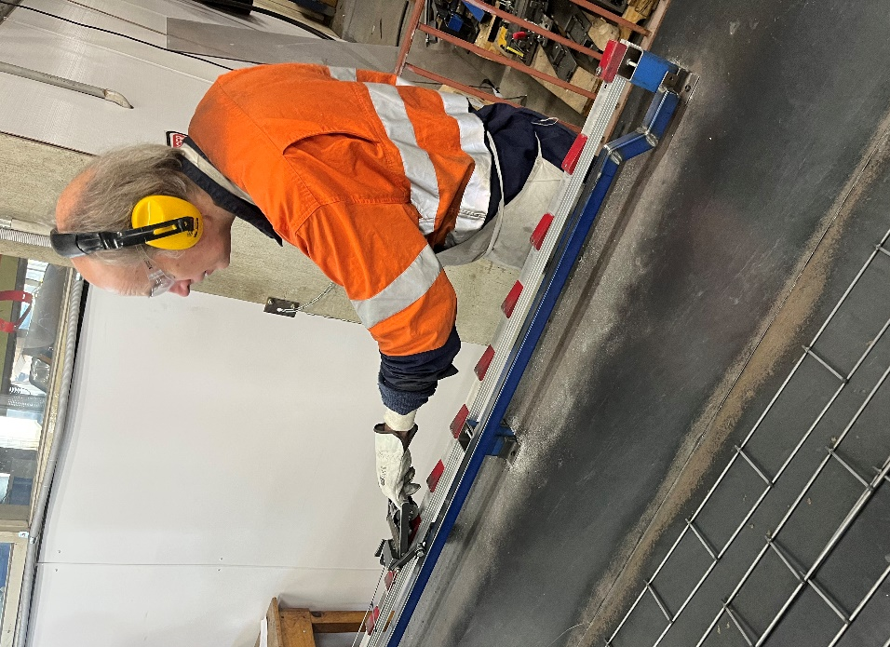
Image description: Jan-Eric eagerly learns a new job in Manufacturing.
Image description: Richard works on the snake mesh, feeding parts into a machine.

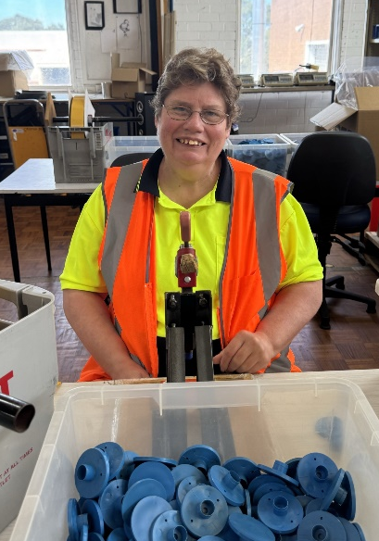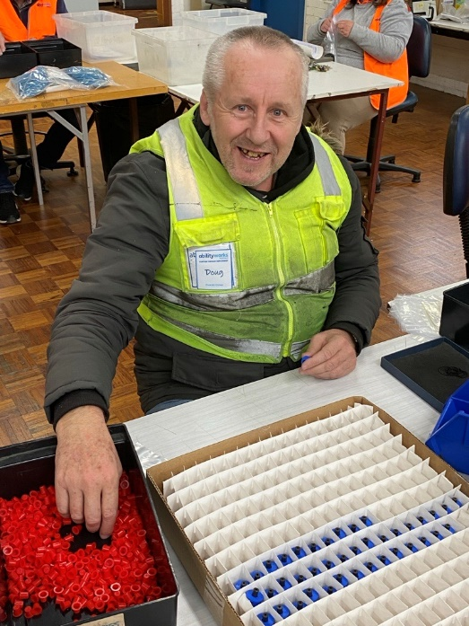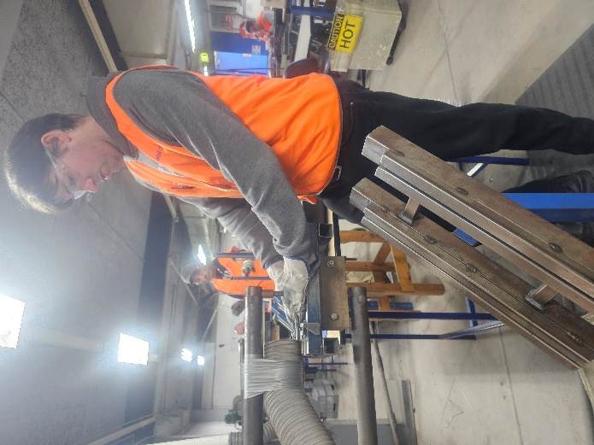
Image description: Belinda works on FLP’s with a smile in Packing and Assembly.
Image description: Doug happily arranges products for a Packing and Assembly job.
Image description: Erik concentrates on his task in Manufacturing.
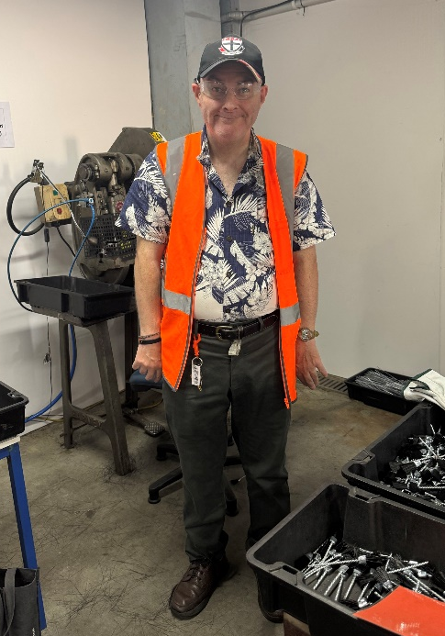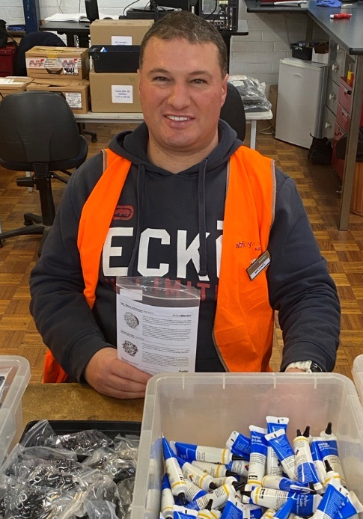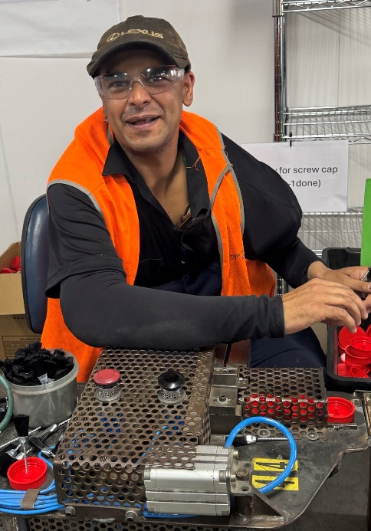
Image description: James stands by the brush jobs with a smile.
Image description: A cheerful Michael smiles for a photo on the Packing and Assembly line.
Image description: Chris skilfully works on brush in Manufacturing.

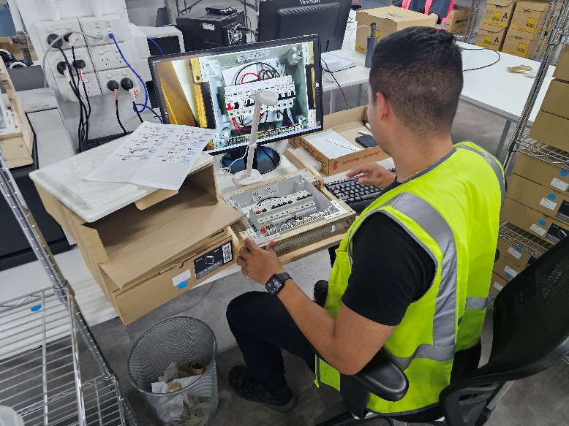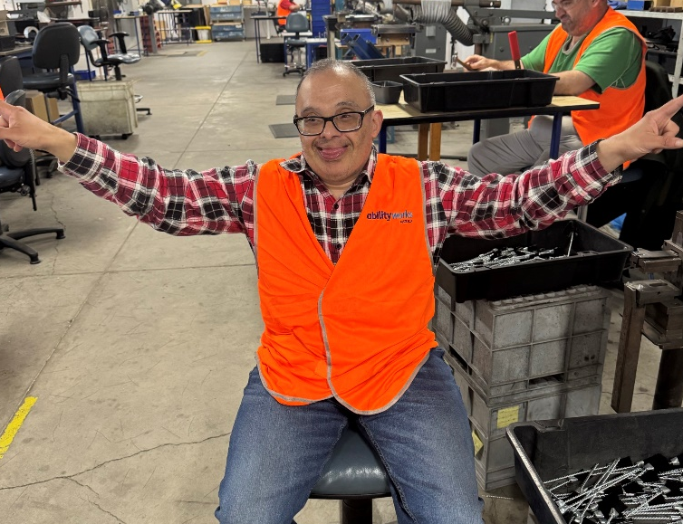
Image description: Carlos shows us how he tests a product for one of our clients.
Image description: John poses cheekily in Manufacturing with his arms stretched out.

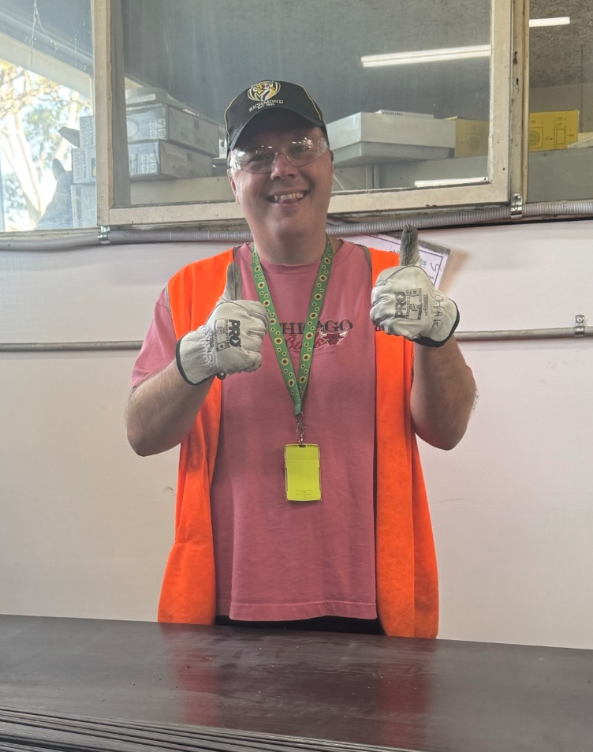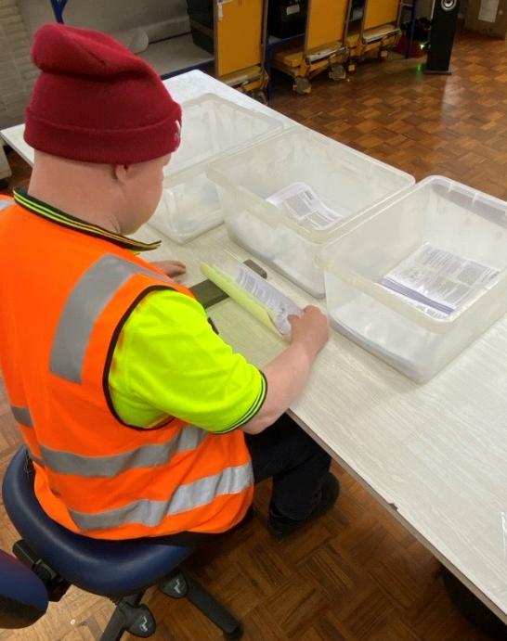
Image description: Josh flashes a thumbs up on the snake mesh line.
Image description: Michael concentrates on his work in Packing and Assembly.

