Ability Works Australia Newsletter
Date: 4 March 2025

In this issue

A note from the CEO 2
Employee shoutout 4
Around the building 5
Global Accessibility Awareness Day 7
Inclusive Design 8
Customised Employment 15
Employee input 18
Photo gallery 20

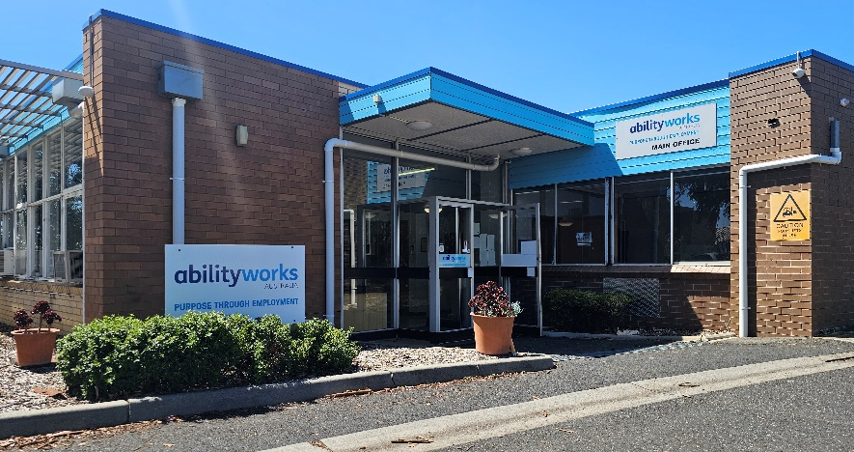

A note from the CEO
Dear Ability Works Community,
Welcome to the March edition of our newsletter! As we step into a new season, I am excited to reflect on the achievements and growth within our organisation.
This quarter, our commitment to inclusion, sustainability, and innovation continues to shine. Our new initiative to recycle pallet wraps marks another step toward reducing our environmental impact. Likewise, our Inclusive Design team has been instrumental in improving accessibility, both internally and in partnerships like the Arts Centre Redevelopment project and our collaboration with Penny. These projects exemplify our dedication to making workplaces, transport, and digital tools more inclusive for all.
A special shout-out to our employees who have gone above and beyond in their roles. Your dedication, patience, and teamwork make Ability Works a great place to be. We also celebrate the contributions of our Employee Representative Committee and their ongoing advocacy for workplace improvements.
Looking ahead, we are thrilled about new job opportunities and the continued expansion of our Customised Employment team, ensuring more individuals can find meaningful roles suited to their strengths.
Finally, as we approach Global Accessibility Awareness Day in May, I encourage everyone to reflect on the importance of inclusion in all aspects of life. Let’s continue striving for a future where everyone has equal access to opportunities.
Thank you for your hard work and commitment to our shared vision.

Best Regards
Sue Boyce
CEO

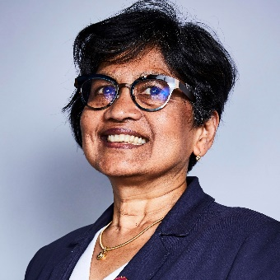
Image: Sue is wearing glasses and a dark blue blazer. She is smiling.

Employee shoutout

Manufacturing – Gary
Congratulations Gary, for being recognised for your dedication to exceptional coil holder welding.

Packing and Assembly – Doug
Congratulations Doug, for being recognised for always being patient and on time.

Mailroom – Neil
Congratulations Neil, for being recognised for really stepping up in your role and always being helpful.
Image 1: Gary is drilling a screw into a vent.
Image 2: Doug is driving the forklift.
Image 3: Neil is sitting at a computer in the mail room.

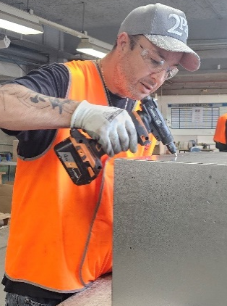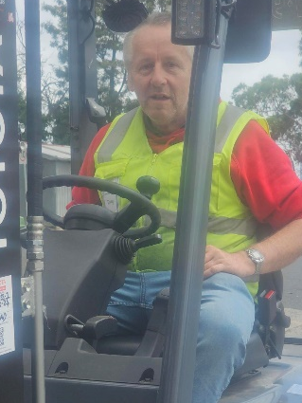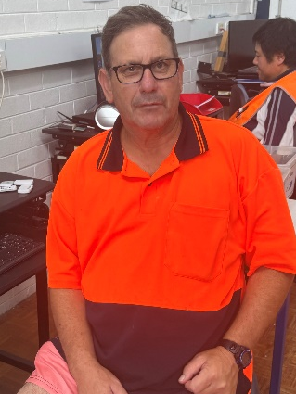

Around the building

New capabilities
We're excited to announce that we can now recycle pallet wrap at Ability Works. This eco-friendly initiative not only helps reduce plastic waste but also supports our commitment to sustainability. By recycling pallet wrap, we're keeping it out of landfills and giving it a new life, which is pretty cool. Let's do our part to protect the planet and make our workplace greener.

New jobs
Gripps: Reworking their “Tethering Station” to include an extra label.
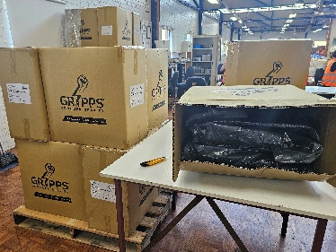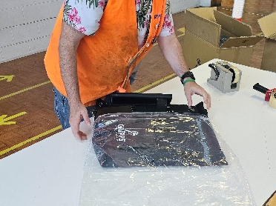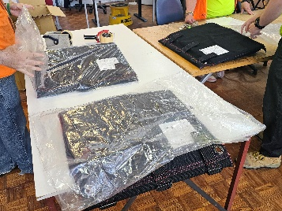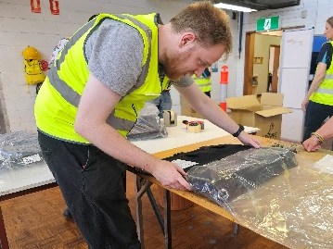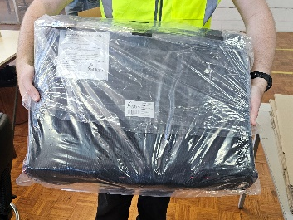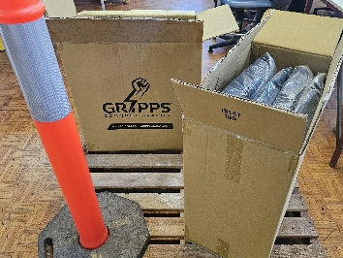
Images: A series of six images depict the process of the product being unpackaged, reworked and repackaged.
Healtheries: Much like our regular “chip job”, reworking Healtheries’ rice wheels, we’ve taken on a new job reworking their cheese flavoured Tasty Tubes.
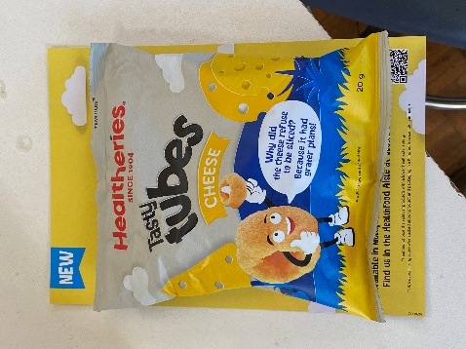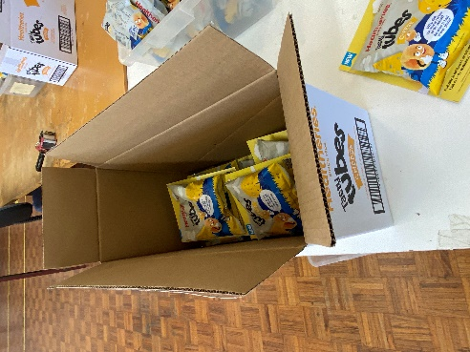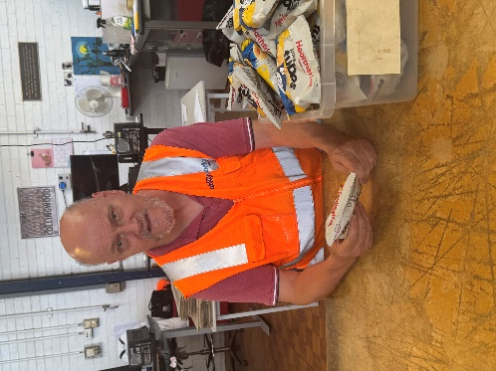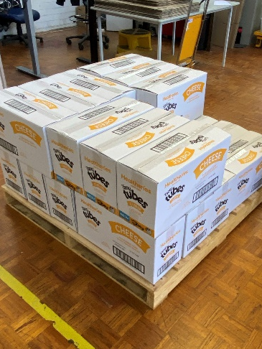
Image: A series of four images depict the process of the product being unpackaged, reworked and repackaged.

Global Accessibility Awareness Day
Global Accessibility Awareness Day (GAAD) is celebrated annually on the third Thursday of May and promotes digital access and inclusion for people with disability. In 2025, GAAD will be observed on Thursday 15 May, with various events and activities to raise awareness and encourage participation.
Accessibility is crucial for fostering an inclusive society, ensuring legal compliance, enhancing user experience, and reaching a diverse audience.
At Ability Works Australia, we are on a journey to improve our processes and services to be more accessible and meet compliance standards. Most importantly, we want to improve accessibility as it reflects social responsibility, drives technological advancement, and creates economic opportunities. By prioritising accessibility, we can create a world where everyone can participate equally and lead fulfilling lives.
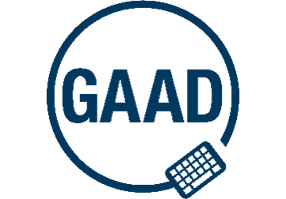Image: The Global Accessibility Awareness Day logo shows a keyboard and circle with the abbreviation “GAAD”.

Inclusive Design

Making Financial Empowerment Accessible: Penny Partners with Ability Works
We are excited to announce our latest collaboration with Penny, a new, innovative app dedicated to empowering women financially.
Penny, founded by the passionate social policy professional Jemi, aims to help women in Australia achieve their financial goals, starting with homebuying. Recognising the importance of accessibility, Jemi reached out to us at Ability Works Australia. By joining forces, we can ensure that Penny's platform is functional, vibrant, and engaging for all women, including those with disabilities.
Morgan, from our Inclusive Design team, has joined Penny's mission, bringing expertise in colour theory and design. Her focus on user-centred design is helping Penny improve accessibility across its tools and communications.
This collaboration highlights our commitment to inclusivity and accessibility, ensuring that women of all abilities can access the tools and resources they need to achieve their financial goals. We are proud to support Penny in creating a more inclusive and accessible platform for all.
Join the Penny community at www.urpenny.com
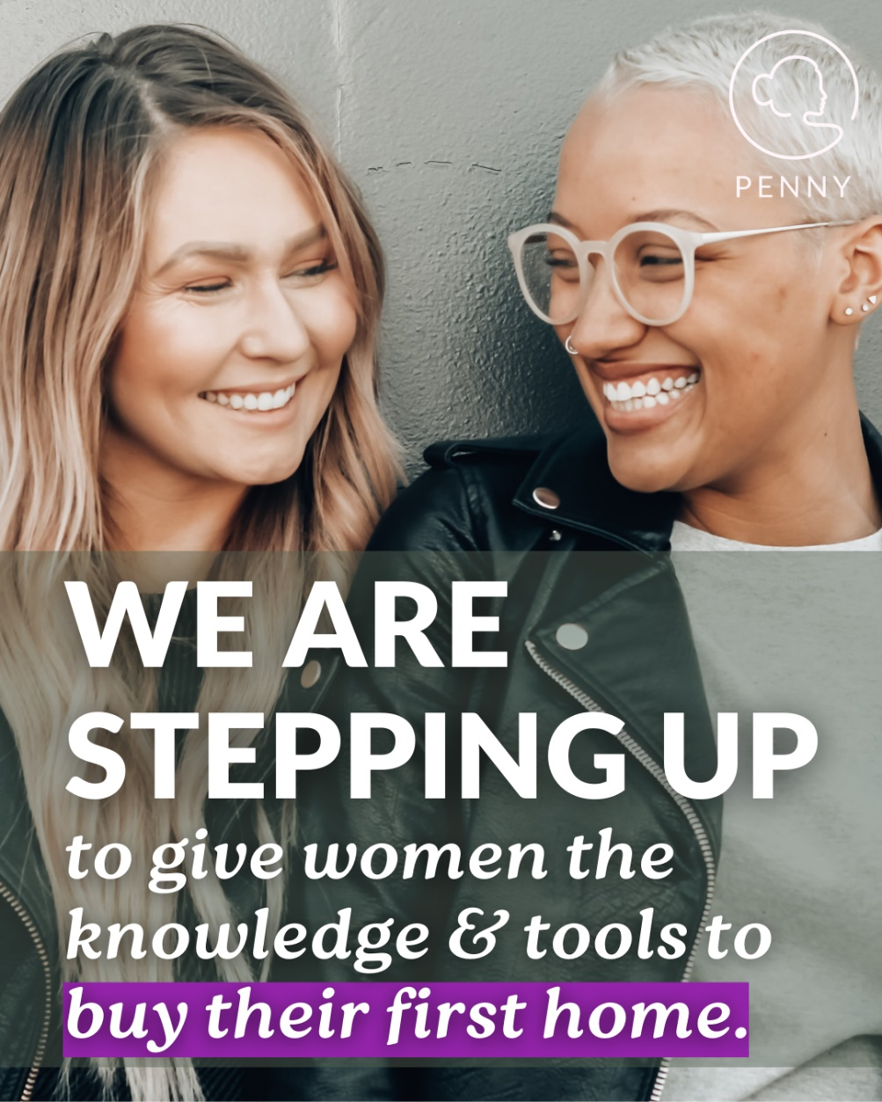
Image: Two women sit closely together, smiling. One has long blonde hair, the other has short white hair and round glasses. Text over the bottom of the image reads "We are stepping up to give women the knowledge & tools to buy their first home."

Accessibility Reference Groups (ARGs) for Public Transport
Dom Loulie, from the Inclusive Design team, is a member of the Accessibility Reference Group (ARG) for many of Victoria’s transport operators. ARG’s include people with lived experience of disability who use public transport, and provide advice to transport operators like Metro Trains, Kinetic Buses, V/Line and Yarra Trams to improve accessibility for everyone.

What the ARGs do:
- Give feedback on new projects: Review infrastructure projects such as the new Anzac train stations, tram super stops and bus interchanges to make sure they are accessible for everyone.
- Look at policies and plans: Give feedback on transport policies and accessibility programs to ensure they meet the needs of people with disabilities.
- Identify barriers: Help spot problems that people with disability face when using public transport.
- Test new systems and technology: Try out new systems like ticketing, wayfinding, apps and digital signs to make sure they work well for everyone.
- Advocate for better standards: Push for better understanding and compliance to accessibility standards to improve public transport for everyone.

Why Dom’s Experience Matters:
“As someone with a hearing loss, my experience helps improve the system for others who face similar challenges. I share my insights to make sure the public transport system is easier for everyone to use.” – Dom Loulie, Inclusive Design Projects Coordinator.
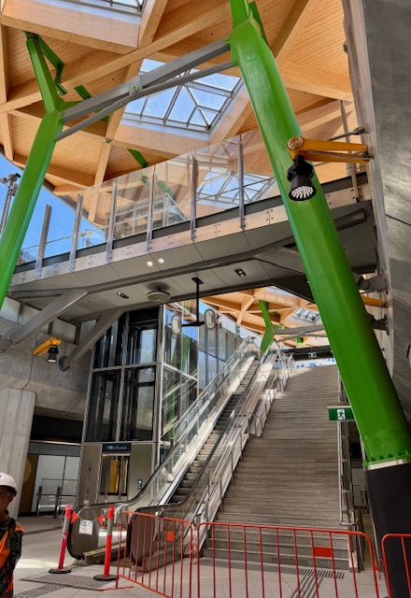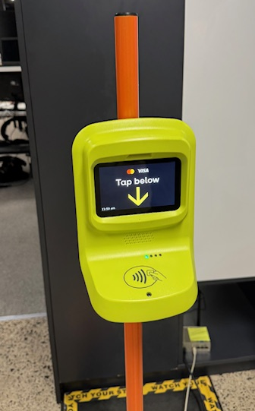
Image 1: A large set of stairs and escalator at a train station are fenced off for renovations.
Image 2: An upgraded myki card scanner.

Improving accessibility and findability of resources
The Inclusive Design Team have been working hard to make our digital assets more accessible and easier to find. Their goal is to follow the W3C Web Content Accessibility Guidelines (WCAG) Level AAA.
They've been focusing on creating an easier way for staff and employees to find important content, like policies and procedures, by adding relevant links to the Intranet. This includes strategy documents, the organisation chart, and consent forms.
The team is also updating material for the Support SharePoint site and OH&S documents, and creating templates for letters, reports, and presentations. Quick links to commonly used folders are being added to the Intranet and Resources Hub, which is being trialled with staff.
These efforts are helping ensure our digital content is accessible and inclusive for everyone.

Arts Centre project review

Participants: Ruby, Mark, Ebony, Manil, Dom
What was tested and how: We checked different areas of the Arts Centre back office to see how easy they are to use for everyone, including new employees, stakeholders and suppliers.

Key areas we reviewed:
- Arriving and Leaving: Public transport access, drop-off points and walking paths. Checked if train stations had clear signs, if trams had ramps and if footpaths were flat with no trip hazards
- Approaching and Entering: Signs, entrances, reception areas and wayfinding. We tested if doors were automatic, if reception desks had a lower section for wheelchair users and if signs had large text or Braille
- Moving Through the Building: Doors, lobby, floors, stairs, lifts, emergency alerts and exits. We checked if doors were wide enough, if the lobby had enough space for wheelchairs, if emergency alerts had flashing lights for people who have hearing loss.
- Work Areas: Desks, meeting rooms, sound, lights and switches. We tested if desks were adjustable, if meeting rooms had good lighting and hearing loops for people with hearing aids and if light switches were at a reachable height.
- Amenities: Kitchens, toilets and lockers. We checked if kitchens had accessible sinks and if accessible toilets had grab bars and enough space for wheelchair users.
- Communication System: Sign-in system for ease of use. We checked if the app had a simple layout and worked with screen readers.

Outcome
The Inclusive Design Team is creating a Workplace Accessibility Assessment report with recommendations to improve accessibility at the Arts Centre back office during its significant redevelopment over the next 2-3 years.
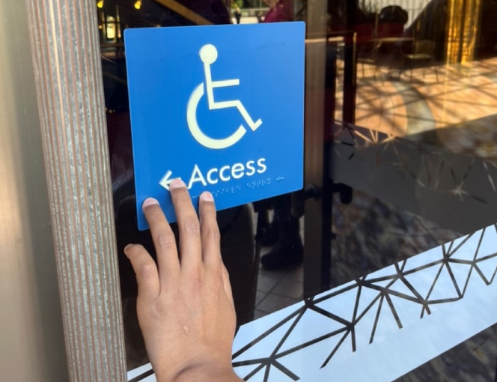
Image: a hand is feeling a disability access sign for braille.

Customised Employment
We’re sure many of you have noticed some new faces wandering around Ability Works, and we’d like to introduce you to a few of them. Over the next few issues of our newsletter, we hope to introduce you to the full Customised Employment team and explain their role within the company.
Customised Employment is a person-centred approach to assisting those experiencing barriers to mainstream employment to find the role that is ideal for them and their circumstances.
The specially trained team meet with interested participants and their support people on a regular basis to get to know the participants interests and skills so they can better understand their strengths and limitations.

Introducing…

Jane: Jane is based in our East Metro team, with over 30 years’ experience in the disability and community health sector as well as several years’ experience in counselling. Her focus is on supporting and empowering people to identify any challenges they may be experiencing in relation to employment and develop strategies to address these.

Aline: Aline is a CE counsellor who focuses on building a strong relationship with participants, identifying their strengths, and working with clients' skills relating to their employment goals using a holistic approach to move to action effectively. Aline is a good listener and likes interacting with people. In her spare time, she likes to walk, run, and be close to nature.

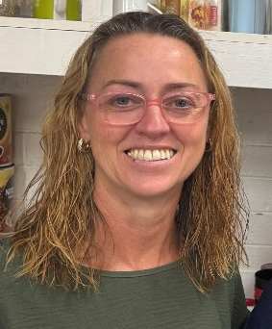

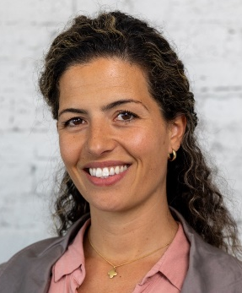
Image 1: Jane is smiling, she has light, mid-length hair and pink glasses.
Image 2: Aline is smiling, she has dark curly hair.

Website updates
The Inclusive Design team has been reviewing and enhancing our website to boost accessibility and optimise user experience. Recently, the team focused on creating a dedicated page for Customised Employment to highlight their services and make the details easier to find. Thanks to the collaborative efforts of Clare from Customised Employment and Bri from Inclusive Design, these improvements are set to be live on our website when this newsletter is released. Be sure to visit our website and explore the exciting changes!
www.abilityworks.com.au
If you or someone you know might be interested in Customised Employment there are many ways you can reach out:
• Let our staff know
• Check out our website
• Call us on 03 9853 7080
• Send an email to info@abilityworks.com.au

Employee input
We occasionally get requests to include items from the employees, this quarter we’ve been sent a riddle from Richard and an image from Jared. If you have something you’d like to share, let the support team know! Please keep it short and appropriate for the workplace.

Richard’s riddle

Who/what am I?
I can be large or small.
I can be hot or cold.
I can be heard.
I can be seen.
I have different sizes.
Many people use me:
- I am used in gardens.
- I am used in the house.
- I am used by musicians.
- I am used by sports people.
- I am used by people when they want to enter somewhere.
- I am used by people when they want attention.
Who/what am I?
(answer on the next page)
Answer: I am a tap.

Jared’s image

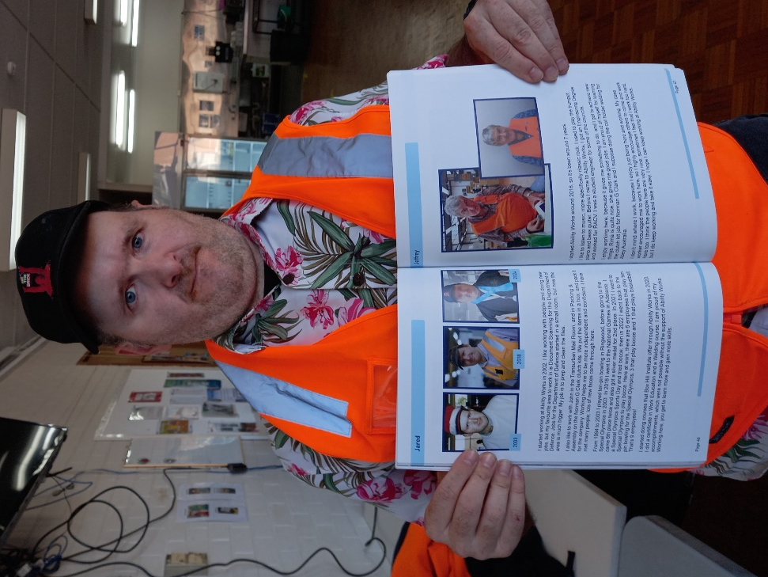
Jared started working at Ability Works Australia 25 February 2002. This image marks year 23!
Image: Jared proudly shows his page in the Ability Works 60 Year anniversary book.

Photo gallery

