Ability Works Australia Newsletter
Date: 1 October 2024

In this issue
A note from the CEO 2
In the spotlight: Andres 4
Transurban collaboration 5
Ability Works’ awards 6
Grants and funding 7
Lift update 9
Important dates 10
Employee shoutouts 12
Inclusive Design Team – project highlights 16
Photo gallery 20
Activities 25

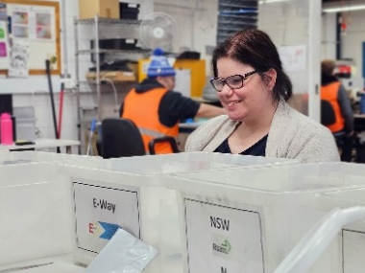
Image 1: Team Leader Ruby is happily working in the mailroom for our Transurban collaboration video.

A note from the CEO
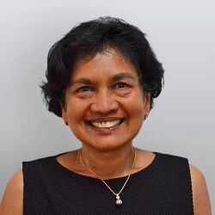
Image 2: A smiling Sue Boyce, wearing a black top and gold necklace.

Innovation and Progress
As we continue to grow and innovate, I’m excited to share some key milestones that reflect our evolution as a business.
Recently, we invested in a new laser cutting machine, enabling us to introduce the production of Traffolyte signage. This new offering has already sparked excitement, and you’ll see Andres, who has been diligently writing the code to streamline our production process, showcase this new capability. This is just one of the ways we are driving efficiency and expanding our product range.
On another exciting note, it’s been truly rewarding to be recognised for our efforts. We’ve had the honour of being named a "Business for Good Gamechanger." It’s wonderful to see the sector acknowledging our mission of creating meaningful impact through inclusive employment.
Looking ahead, we have some remarkable projects underway in Inclusive Design. You’ll read about some of the various initiatives we are working on, including a recent grant from the Victorian Government. This funding will help us develop solid products for corporates, further enhancing our Inclusive Design service. Additionally, a grant from the Federal Government will allow us to refine our service offering, supporting current employees who aspire to transition into mainstream employment or explore hybrid work models—spending a couple of days in a mainstream workplace and a couple of days with us.
Have you noticed this newsletter looks different? Morgan, in collaboration with our Inclusive Design team, has been working hard to enhance accessibility for all readers. A big congratulations to Morgan for doing an outstanding job. 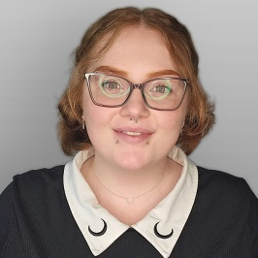
Image 3: Morgan is smiling, she is wearing a collared shirt and glasses.
I look forward to sharing more updates soon.
Till next time.

In the spotlight: Andres
We're thrilled to celebrate the remarkable achievements of Andres, whose exceptional coding skills have made a significant impact at Ability Works. Andres has developed innovative software that enables us to offer a Traffolyte signage service, improving both efficiency and precision in our production process. His creativity, problem-solving abilities, and technical expertise have truly exceeded our expectations.
Originally from Colombia, Andres has brought a wealth of experience in software engineering consulting, where he specialised in automating electrical substations. He came to Australia to hone his English language skills and is making incredible strides in his job here at Ability Works. We're proud to have him as part of our team!
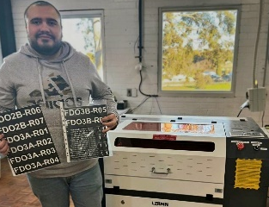
Image 4: Andres is standing beside a laser cutting and engraving machine, showing off some recently made product.

Transurban collaboration
In July we worked together with Sebastian Conley from Transurban to create a video commemorating our 13-year partnership that has created numerous employment opportunities.
Currently we manage Transurban’s mail room services and e-tag testing/sorting/cleaning and distribution, but the potential for other services we could offer them is extensive. With our manufacturing, packing and assembly, and inclusive design services Ability Works hopes to further strengthen our relationship with Transurban and continue to expand and foster a more inclusive industry.
A lot goes into the back end of creating a video with accessibility in mind. Having a clear cohesive script for everyone to follow helps us to ensure we can provide accurate transcripts, closed captioning, audio descriptive overlays and even AUSLAN interpretation.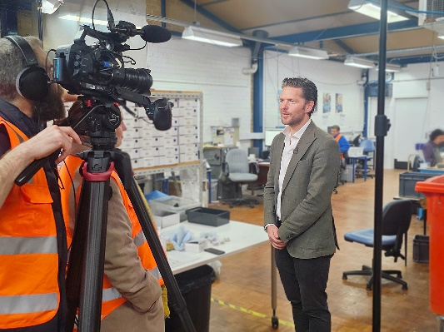
Image 5: Sebastian from Transurban is standing in front of a camera, with the Ability Works mail room behind him.

Ability Works’ awards

Third Sector Award
In July 2024, Ability Works was announced as a finalist for the Third Sector Digital Innovation Award in collaboration with Transurban. The Third Sector aims to recognise non-profit organisations that have leveraged digital technology, social media or online platforms creatively and effectively to raise awareness, mobilise support, deliver services or drive social change in innovative ways.
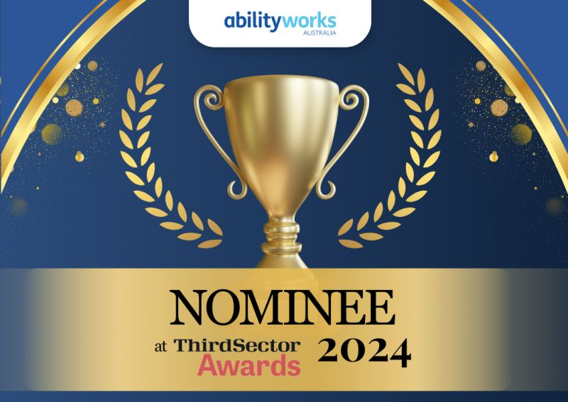
Image 6: a generated image of a gold trophy cup and leaves on a dark blue background, with the words “Nominee at Third Sector Awards 2024”.

Social Traders Award
In June 2024 Sue Boyce and Ability Works were awarded the Social Traders’ Business for Good Gamechanger Vic/Tas award for achievements in employment expansion, innovation and technology, and advocacy and support. Board member James Edmonds attended the event and accepted the award on Sue's behalf, as she was unable to attend.
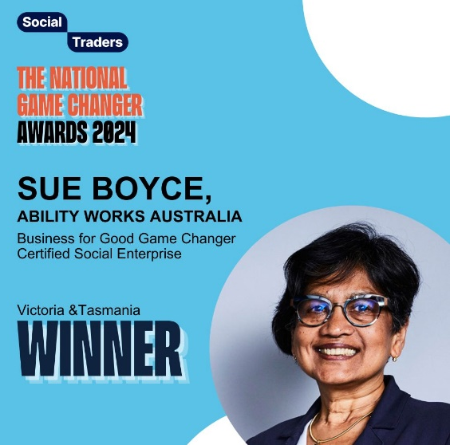
Image 7: A smiling Sue Boyce wearing glasses and a dark navy blazer The text reads: “Social Traders. The National Game Changer Awards 2024.Sue Boyce, Ability Works Australia. Business for Good Game Changer Certified Social Enterprise. Victoria and Tasmania Winner.

Grants and funding

Structural adjustment fund
Ability Works has started an exciting project with the Department of Social Services to help Ability Works employees find jobs with external organisations. This project, announced by Minister Rishworth in April, is led by the Customised Employment team. They work closely with employees to find jobs that match their skills and interests.
Thanks to this innovative approach, Ability Works is one of only eight organisations in Victoria to receive special funding. The project aims to help at least 16 employees find meaningful jobs over the next two years. Employees interested in this opportunity should talk to the support team for more information.
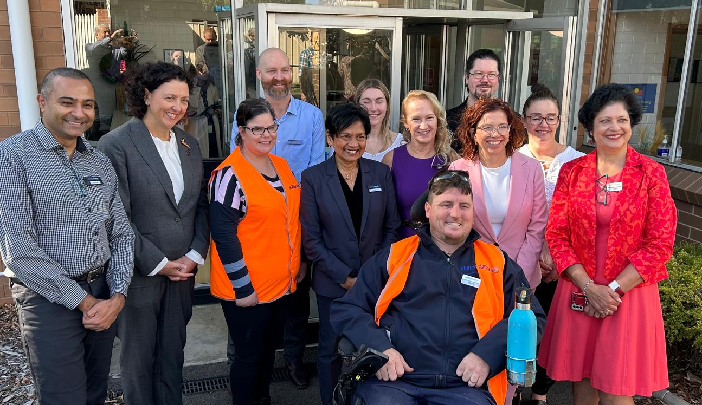
Image 8: a group of cheerful Ability Works’ staff and two of our Team leaders pose with Minister Rishworth during their visit in April.

Skills Solutions Partnership Grant with Swinburne University
Ability Works’ Inclusive Design team is excited about successfully winning a significant grant from the Victorian government. This grant will enable the Inclusive Design team to build disability inclusion consulting and training, co-designing with people with lived experience of a disability to deliver practical and inclusive employment initiatives with organisations.
Working together with Swinburne University, the team will build a Skills Gap Assessment and Evaluation Tool, supported with unaccredited micro-credentials training by the end of the 12-month grant period. After the grant period there will be work to do to progress the training to accredited micro-credential training.
We are looking to work with organisations interested in being involved in the research being conducted to build an inclusive culture, please contact InclusiveDesign@AbilityWorks.com to be a part of our focus groups and interviews.

Lift update
We have been working with Austin Health on plans to upgrade our lift and are glad they will be managing this project. A builder has been selected and we are awaiting confirmation of funding from Job Access. This has been an extensive process, and we extend thanks to all of the employees that made themselves available and specifically came in for an assessment by Job Access.

Important dates

End of Year Party – Thursday 19 December
We have an African drumming experience by Asanti Dance Theatre booked for the End of Year Party. It will include a 1-hour long performance featuring 40 drums, and there will be an opportunity for the audience to get involved and participate.
The theme for this year’s End of Year Party is “Culture Pride”. We encourage everyone to dress in a way that embraces their ancestry with pride and comfort.
More details will be shared soon.

Image 9: A man is happily drumming , wearing colourful clothes against a yellow background. The text reads: “Asanti Dance Theatre. West African drum, dance and afrobatics. Available for festivals, parties, corporate, team building, schools, childcare. All enquires 0407819816. Social media is @asantidancetheatre

Add these dates to your calendar
- End of Year Party – Thursday 19 December

- There will be work on Friday 20 December and Monday 23 December

- Tuesday 24 December will be an RDO

- Public Holidays are on Wednesday 25 December and Thursday 26 December

- Take your annual leave Friday 27 December to Friday 3 January 2025

- AWA will be fully closed until Friday 3 January 2025

- AWA will resume work with a skeleton crew on Monday 6 January 2025

- Full operations resume on Monday 20 January 2025

- Australia Day Holiday – Monday 27 January 2025

Employee shoutouts

Peter - Manufacturing
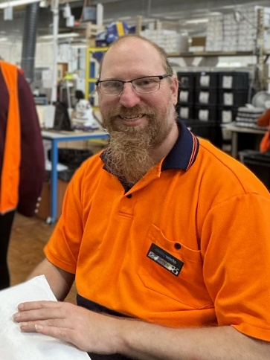
Image 10: A smiling Peter is sitting in the mail room, wearing glasses and an orange shirt.
Peter has received this shoutout for really stepping up in manufacturing, going above and beyond training other employees and even writing his own Standard Operating Procedure (SOP) to help others to learn on the job.
Peter enjoys making people happy at work and getting to put his skills to a great use. His favourite thing about coming to work is getting out of the house and making friends. He is working toward a goal of receiving a worker of the year award.

Jimmy – Packing and Assembly
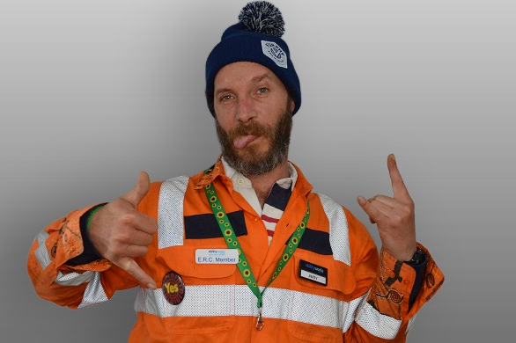
Image 11: A cheeky Jimmy is showing his personality with hand signs and a tongue out.
Jimmy has received this shoutout for always making an effort to interact with and teach fellow employees. For caring, bringing positivity, being patient with others, and for showing an outstanding attention to detail.
Jimmy said he feels honoured and pleased to have his efforts noticed and to know that he is making a difference. He loves his professional and friendly interactions with his colleagues and staff. His favourite thing about coming to work is his connection with the community, knowing he is part of a caring and professional place full of personal achievements.
He enjoys making sure he gets his jobs done to a high standard and being part of a team where everyone is working and learning together. Jimmy would love to learn to use the laser cutter and new roles in the mail room.

Stephen – Mail Room Services
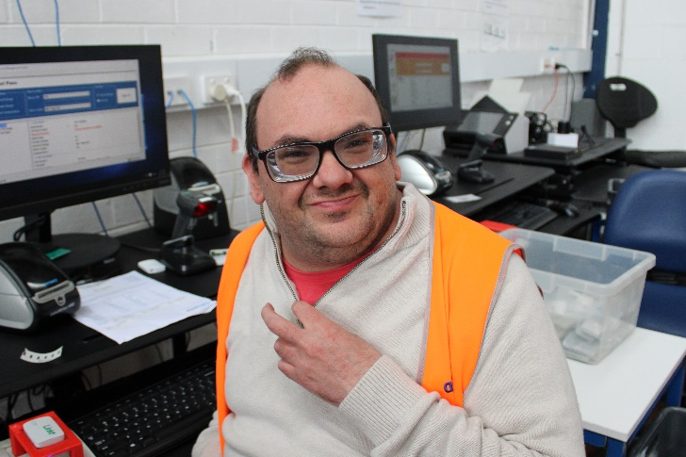
Image 12: Stephen is smiling, sitting in front of a computer in our mail room.
Stephen deserves this shoutout for consistently being helpful, returning from breaks on time, and completing his tasks efficiently without complaint. He finds joy in his work at Ability Works, particularly enjoying his role in the mailroom alongside John.
His favourite job is scanning and sorting E-tags for Transurban and is proud of himself for making new personal achievements on E-tag scanning and making more friends.

Mario – Honorable mention
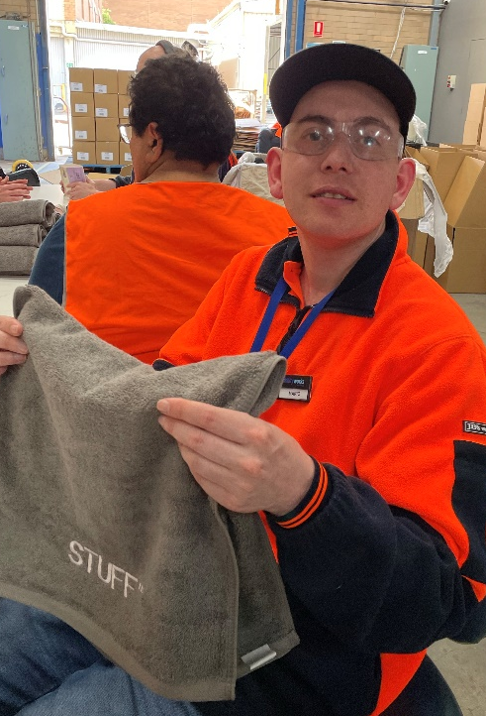
Image 13: Mario is wearing safety glasses and a cap, showing off a STUFF towel from one of our past Packing and Assembly jobs.
Special recognition goes to Mario for his adaptability in taking on a variety of tasks and his dedication to improving his communication skills.
Congratulations Mario on the great progress!

Inclusive Design Team – project highlights

Swinburne University students are designing an accessible tap
The Inclusive Design team and Ability Works’ employees have been assisting Engineering and Design students from Swinburne University with a project to design a tap that might be found in a public area around Melbourne. They have discussed things like accessibility for those in wheelchairs or with limited mobility, as well as temperature control. What kinds of taps may be easy to operate, and which aren’t.
The students brought many sketches for our teams’ feedback in terms of tap placement, soap options and basin size. Pros and cons considered included:
- How easy are the taps to maneuver?
- How easy is the temperature to control?
- How easy is it to figure out what is hot and what is cold?
- Is there braille on the tap?
- What kinds of materials could be used?
The participants found it interesting to learn that the current national standard for an accessible bathroom mostly calls for sensor taps where the general consensus was that these taps aren’t well liked or user friendly. Another consideration that came up was the need for space beneath the basin so those in wheelchairs can get closer to the tap.
We look forward to seeing the outcomes of this project and what the students at Swinburne University decide to design.
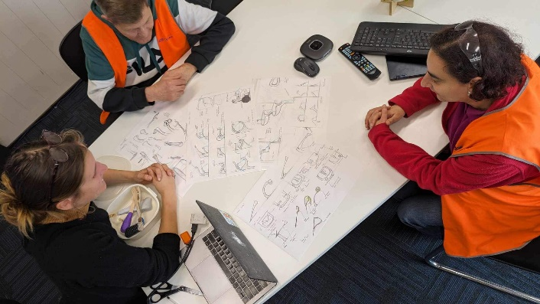
Image 14: A Swinburne University student is sitting at a table covered in tap design sketches with 2 Ability Works’ employees.

Big Plans Melbourne
Mark at Ability Works recently did a full-scale walk-through of a new plan. This lets him see and understand the design in 3D before it’s built. It’s a great example of inclusive innovation, helping to find and fix problems early.
The walk-through used life-sized floor plans from Big Plans, giving a real view of the space. This method is changing how we design accessibility, making it easier to create spaces that work for everyone.
You can see Mark on 10 News First, where he shows how these life-sized plans are improving accessibility and design. The segment highlights how this approach is helping to make more inclusive environments.
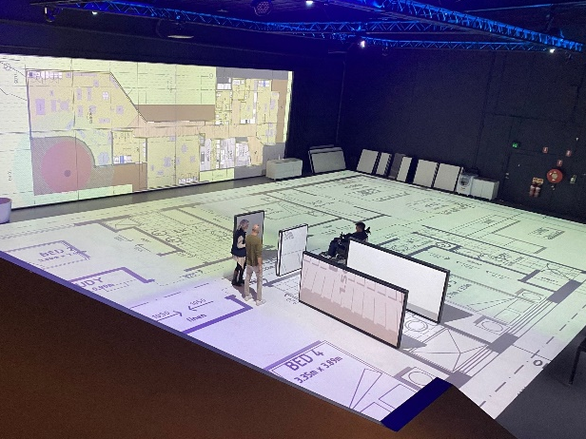
Image 15: Mark uses a wheelchair. He goes through a full-size floor plan. This helps him understand space better before it is built.

Financial Wellbeing Program
We’re excited to share that Ability Works is delivering a custom-designed Financial Wellbeing Program to its employees with the support of White Box Enterprises.
This program is designed to help our staff learn about important money topics in an easy and clear way.
The program covers essential subjects such as understanding pay slips, handling taxes, managing superannuation, budgeting effectively, and spotting scams. It’s created to be simple so that any staff member at Ability Works can use it and share it with others.
Our goal is to make sure everyone at Ability Works has the knowledge they need to manage their finances confidently and safely. We hope this program will be a valuable resource for all our staff.
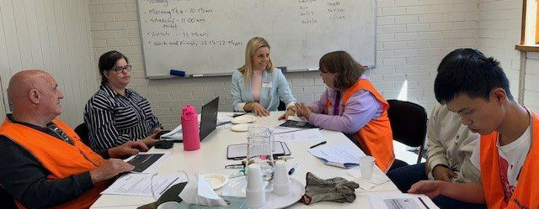
Image 16: Kelly from White Box Enterprises is facilitating a workshop activity, surrounded by five Ability Works employees around a table who are discussing different financial wellbeing topics.

Photo gallery
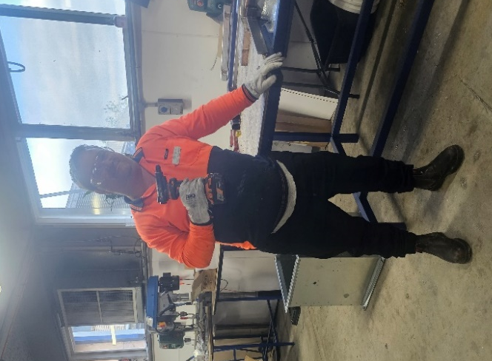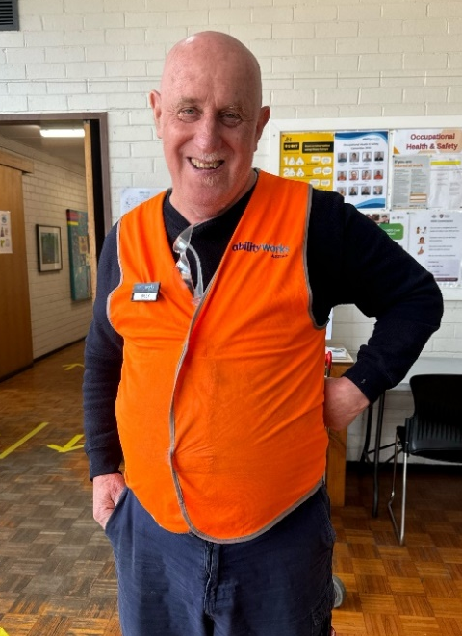
Image 17: James W holding a drill with a big smile in Manufacturing.
Image 18: Billy being his smiley self in the Ability Works lunchroom.
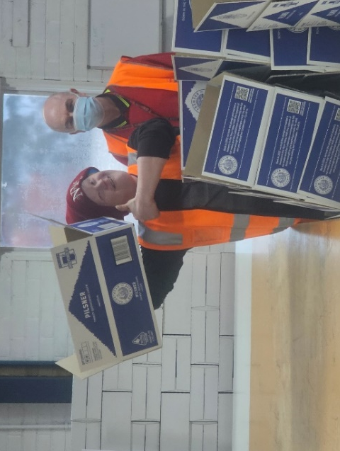
Image 19: A cheeky Michael B showing his well folded Pilsner box with a thumbs up. Michael W can be seen behind him.
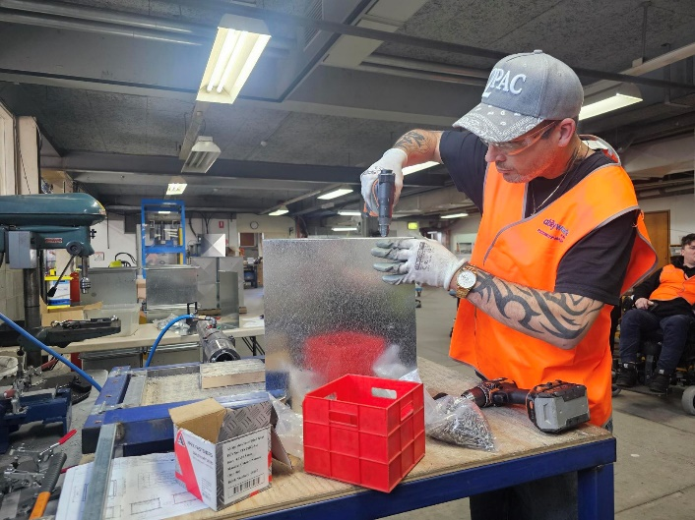
Image 20: Gary working hard in manufacturing, drilling for Pacific Ventilation.
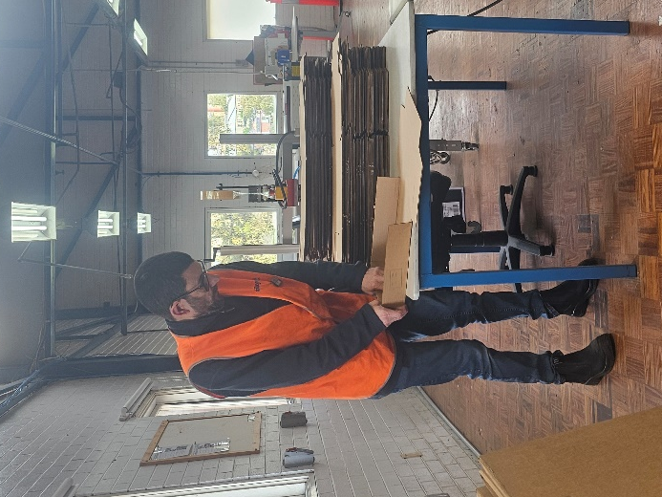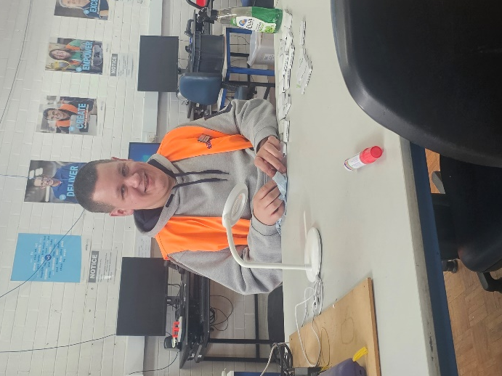
Image 21: Ben R folding boxes in Packing and Assembly.
Image 22: A smiling Dridan cleaning E-tags for Transurban in our mailing room.
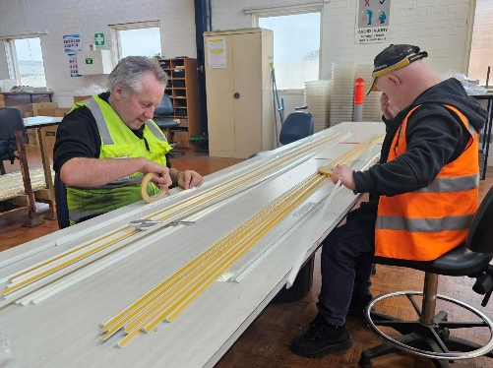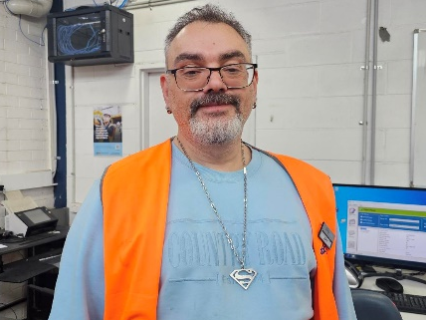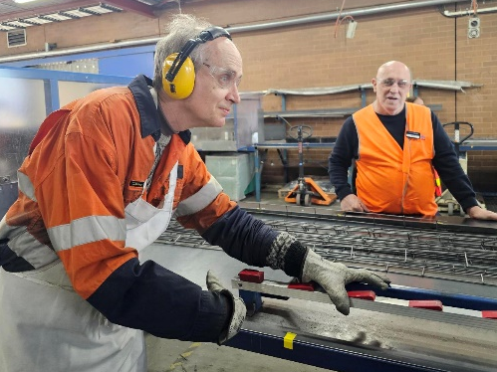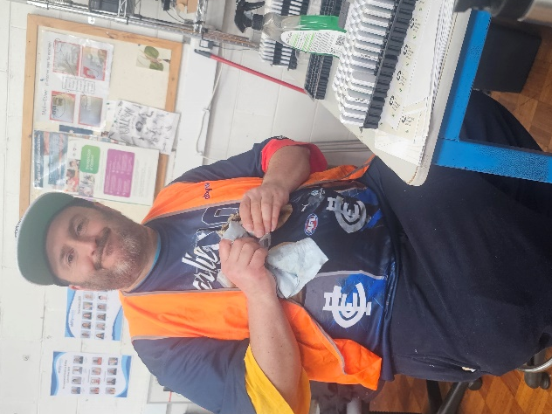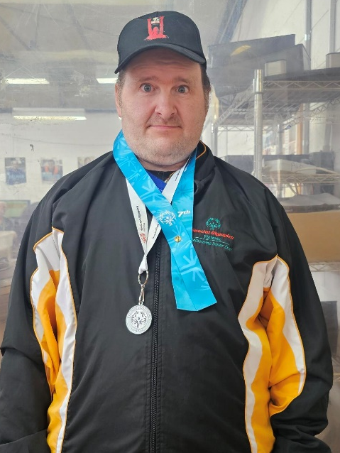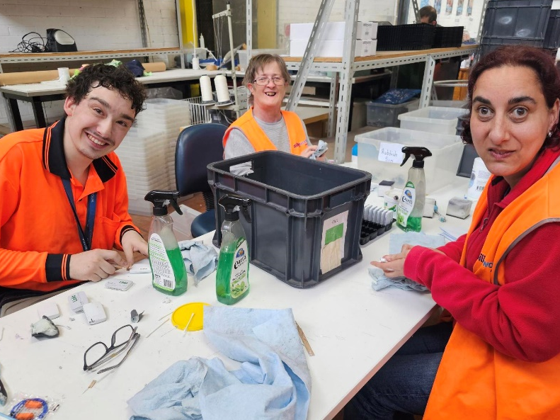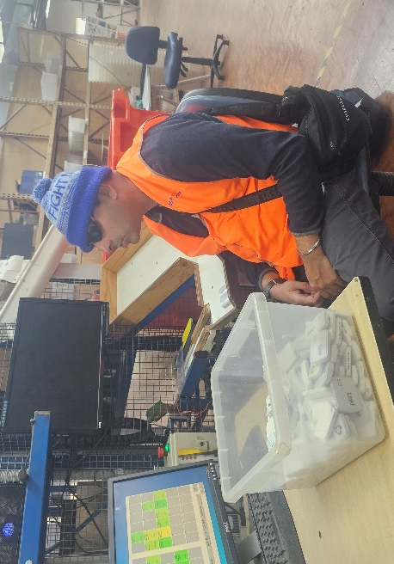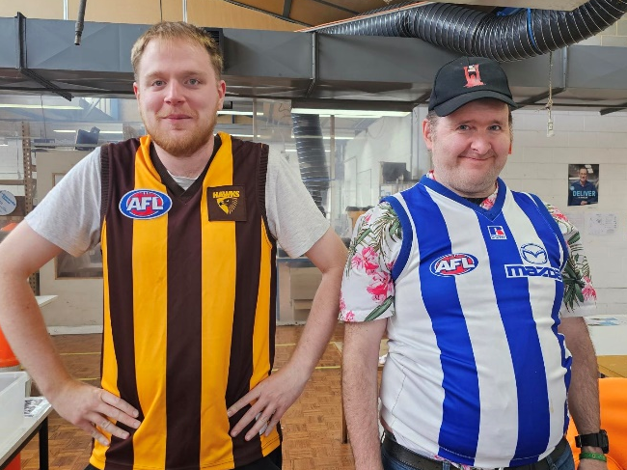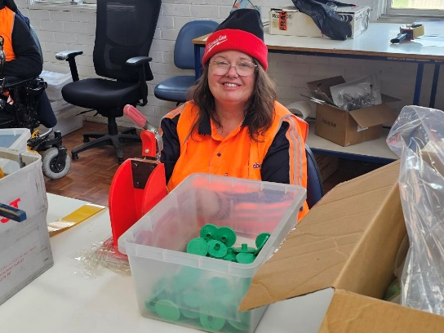
Image 23: Doug and Michael B working on a new job in Packing and Assembly.
Image 24: John L smiling in the mail room.
Image 25: Richard working hard in manufacturing, wearing all his PPE. Billy is smiling in the background.
Image 26: David W working hard in the mail room, cleaning e-tags.
Image 27: A proud Jared wearing his Special Olympics jacket with 2 awards hung around his neck.
Image 28: Luke, Suzie and Nadia make a great team in the mail room, smiling while they clean e-tags.
Image 29: Rabinder working hard in the mailroom on his favourite job – the robot.
Image 30: Proud footy fans, Edward and Jared, wearing their team colours.
Image 31: Diane showing a smile in Packing and Assembly.

Activities

Word Search
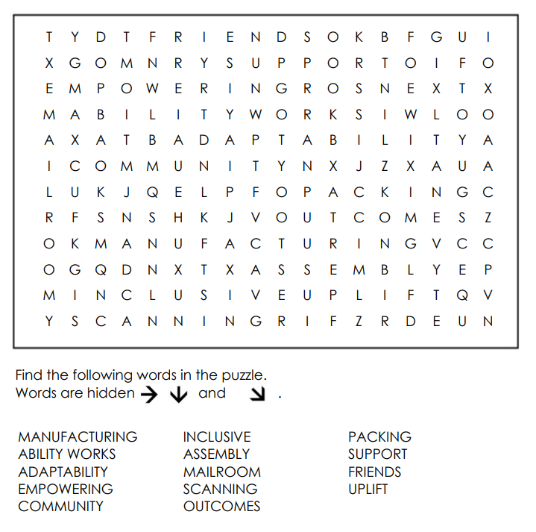
Image 32: A word search puzzle featuring Ability Works themed words.

Spot the hazards
Can you find all 8 safety hazards in this office?
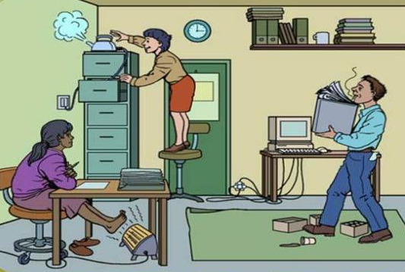
Image 33: An illustrated image of a hazardous office space.

